
Danmarks Tekniske Universitet
Department of Civil Engineering

Multi-Sample Comparison Report
Hydraulic Conductivity Analysis - 15 Samples
Project: DTU Sustiain
Date: June 23, 2026

Multi-Sample Comparison Report
Project | DTU Sustiain
Report Date | June 23, 2026 at 20:20
Number of Samples: 15
Temperature: 20 °C
Porosity: Varies by sample (0.26 to 0.435)

Executive Summary
Comparison Analysis: This report compares 15 soil samples based on grain size distribution and hydraulic conductivity estimates.
Key Findings:
- Highest permeability: Sample_1_Odong (9.54e-04 m/s)
- Lowest permeability: Example_2_Case_1_Vukovic_15C (1.14e-06 m/s)
- Permeability range: 837.4x difference

Methodology

Comparative Analysis Approach
This comparison report presents a side-by-side analysis of multiple soil samples to identify patterns, variations, and relationships between grain size characteristics and hydraulic conductivity estimates.

Analysis Components
Grain Size Comparison: Overlapping distribution curves allow visual assessment of particle size variations between samples.
K-Value Comparison: Box plots and statistical summaries reveal the range and reliability of hydraulic conductivity estimates across samples.
Method Reliability: A reliability matrix shows which empirical methods are applicable for each sample, helping identify the most suitable estimation approaches.

Results & Analysis

Sample Overview
Sample | Temp (°C) | Porosity | D10 (mm) | D50 (mm) | D60 (mm) | Cu | Soil Type | K geometric mean (m/s)
Example_1_Case_1_Vukovic | 20.00 | 0.384 | 0.150 | 0.485 | 0.550 | 3.67 | Poorly-graded sand | 2.73e-04
Example_1_Case_2_Vukovic_15C | 20.00 | 0.384 | 0.150 | 0.480 | 0.550 | 3.67 | Poorly-graded sand | 2.74e-04
Example_2_Case_1_Vukovic_15C | 20.00 | 0.26 | 0.014 | 0.210 | 0.300 | 21.43 | Well-graded sand | 1.14e-06
Sample_1_Odong | 20.00 | 0.346 | 0.341 | 1.181 | 1.886 | 5.53 | Poorly-graded sand | 9.54e-04
Thomson_SERDP_Borden_Sand | 20.00 | 0.407 | 0.070 | 0.180 | 0.195 | 2.79 | Poorly-graded sand | 5.01e-05
NBAL-01 [English] | 20.00 | 0.435 | 0.171 | 0.295 | 0.319 | 1.86 | Poorly-graded sand | 3.64e-04
NBAL-02 [English] | 20.00 | 0.399 | 0.255 | 0.655 | 0.785 | 3.08 | Poorly-graded sand | 7.45e-04
NBAL-03 [English] | 20.00 | 0.405 | 0.122 | 0.305 | 0.350 | 2.86 | Poorly-graded sand | 1.94e-04
NBAL-04 [English] | 20.00 | 0.35 | N/A | 0.173 | 0.205 | N/A | Sand | 8.50e-05
NBAL-05 [English] | 20.00 | 0.419 | 0.098 | 0.192 | 0.233 | 2.38 | Poorly-graded sand | 1.21e-04
NBAL-06 [English] | 20.00 | 0.421 | 0.257 | 0.526 | 0.592 | 2.30 | Poorly-graded sand | 8.28e-04
NBAL-07 [English] | 20.00 | 0.425 | 0.219 | 0.425 | 0.473 | 2.16 | Poorly-graded sand | 6.05e-04
NBAL-08 [English] | 20.00 | 0.423 | 0.125 | 0.244 | 0.281 | 2.25 | Poorly-graded sand | 1.94e-04
NBAL-09 [English] | 20.00 | 0.432 | 0.164 | 0.297 | 0.325 | 1.97 | Poorly-graded sand | 3.38e-04
NBAL-10 [English] | 20.00 | 0.394 | 0.178 | 0.516 | 0.583 | 3.27 | Poorly-graded sand | 4.18e-04

Grain Parameters Comparison
Parameter | Sample | Value
D10 (mm) | Example_1_Case_1_Vukovic | 0.150
D10 (mm) | Example_1_Case_2_Vukovic_15C | 0.150
D10 (mm) | Example_2_Case_1_Vukovic_15C | 0.014
D10 (mm) | Sample_1_Odong | 0.341
D10 (mm) | Thomson_SERDP_Borden_Sand | 0.070
D10 (mm) | NBAL-01 [English] | 0.171
D10 (mm) | NBAL-02 [English] | 0.255
D10 (mm) | NBAL-03 [English] | 0.122
D10 (mm) | NBAL-04 [English] | -
D10 (mm) | NBAL-05 [English] | 0.098
D10 (mm) | NBAL-06 [English] | 0.257
D10 (mm) | NBAL-07 [English] | 0.219
D10 (mm) | NBAL-08 [English] | 0.125
D10 (mm) | NBAL-09 [English] | 0.164
D10 (mm) | NBAL-10 [English] | 0.178
D10 (mm) summary | Included samples | Mean: 0.165 Std: 0.081
D50 (mm) | Example_1_Case_1_Vukovic | 0.485
D50 (mm) | Example_1_Case_2_Vukovic_15C | 0.480
D50 (mm) | Example_2_Case_1_Vukovic_15C | 0.210
D50 (mm) | Sample_1_Odong | 1.181
D50 (mm) | Thomson_SERDP_Borden_Sand | 0.180
D50 (mm) | NBAL-01 [English] | 0.295
D50 (mm) | NBAL-02 [English] | 0.655
D50 (mm) | NBAL-03 [English] | 0.305
D50 (mm) | NBAL-04 [English] | 0.173
D50 (mm) | NBAL-05 [English] | 0.192
D50 (mm) | NBAL-06 [English] | 0.526
D50 (mm) | NBAL-07 [English] | 0.425
D50 (mm) | NBAL-08 [English] | 0.244
D50 (mm) | NBAL-09 [English] | 0.297
D50 (mm) | NBAL-10 [English] | 0.516
D50 (mm) summary | Included samples | Mean: 0.411 Std: 0.252
D60 (mm) | Example_1_Case_1_Vukovic | 0.550
D60 (mm) | Example_1_Case_2_Vukovic_15C | 0.550
D60 (mm) | Example_2_Case_1_Vukovic_15C | 0.300
D60 (mm) | Sample_1_Odong | 1.886
D60 (mm) | Thomson_SERDP_Borden_Sand | 0.195
D60 (mm) | NBAL-01 [English] | 0.319
D60 (mm) | NBAL-02 [English] | 0.785
D60 (mm) | NBAL-03 [English] | 0.350
D60 (mm) | NBAL-04 [English] | 0.205
D60 (mm) | NBAL-05 [English] | 0.233
D60 (mm) | NBAL-06 [English] | 0.592
D60 (mm) | NBAL-07 [English] | 0.473
D60 (mm) | NBAL-08 [English] | 0.281
D60 (mm) | NBAL-09 [English] | 0.325
D60 (mm) | NBAL-10 [English] | 0.583
D60 (mm) summary | Included samples | Mean: 0.508 Std: 0.404
Cu | Example_1_Case_1_Vukovic | 3.67
Cu | Example_1_Case_2_Vukovic_15C | 3.67
Cu | Example_2_Case_1_Vukovic_15C | 21.43
Cu | Sample_1_Odong | 5.53
Cu | Thomson_SERDP_Borden_Sand | 2.79
Cu | NBAL-01 [English] | 1.86
Cu | NBAL-02 [English] | 3.08
Cu | NBAL-03 [English] | 2.86
Cu | NBAL-04 [English] | -
Cu | NBAL-05 [English] | 2.38
Cu | NBAL-06 [English] | 2.30
Cu | NBAL-07 [English] | 2.16
Cu | NBAL-08 [English] | 2.25
Cu | NBAL-09 [English] | 1.97
Cu | NBAL-10 [English] | 3.27
Cu summary | Included samples | Mean: 4.23 Std: 4.86
Cc | Example_1_Case_1_Vukovic | 1.48
Cc | Example_1_Case_2_Vukovic_15C | 1.57
Cc | Example_2_Case_1_Vukovic_15C | 1.50
Cc | Sample_1_Odong | 0.54
Cc | Thomson_SERDP_Borden_Sand | 1.56
Cc | NBAL-01 [English] | 1.10
Cc | NBAL-02 [English] | 0.84
Cc | NBAL-03 [English] | 1.08
Cc | NBAL-04 [English] | -
Cc | NBAL-05 [English] | 0.92
Cc | NBAL-06 [English] | 1.03
Cc | NBAL-07 [English] | 1.06
Cc | NBAL-08 [English] | 0.88
Cc | NBAL-09 [English] | 1.06
Cc | NBAL-10 [English] | 1.40
Cc summary | Included samples | Mean: 1.15 Std: 0.30

K-Value Aggregate Summary
Scope | Datasets | K geometric mean (m/s) | K arithmetic mean (m/s) | K median (m/s) | ln(K) std dev | Included K cells | Warning cells | Permeability class
Overall | 15 | 2.49e-04 | 4.88e-04 | 3.02e-04 | 1.525 | 188 / 240 | 52 | High (Clean Sand)
test | 3 | 3.98e-04 | 6.39e-04 | 3.44e-04 | 0.931 | 40 / 48 | 8 | High (Clean Sand)
test2 | 2 | 1.15e-05 | 4.10e-05 | 3.41e-05 | 2.261 | 18 / 32 | 14 | Moderate (Fine Sand)
test3 | 7 | 3.44e-04 | 5.53e-04 | 3.99e-04 | 1.060 | 89 / 112 | 23 | High (Clean Sand)
test4 | 3 | 3.01e-04 | 3.97e-04 | 2.73e-04 | 0.716 | 41 / 48 | 7 | High (Clean Sand)

K-Value Calculations by Dataset and Method
Sample | Method | K (m/s) | K (m/d) | Status | Included in Mean | Notes
Example_1_Case_1_Vukovic | Hazen | 3.00e-04 | 25.93 | OK | Yes | OK
Example_1_Case_1_Vukovic | Hazen_1892 | 2.25e-04 | 19.44 | Error | No | Empirical mm² variant (10°C reference)
Example_1_Case_1_Vukovic | Slichter | 9.60e-05 | 8.29 | OK | Yes | OK
Example_1_Case_1_Vukovic | Terzaghi | 1.67e-04 | 14.43 | OK | Yes | Reference 10°C calibration
Example_1_Case_1_Vukovic | Beyer | 2.48e-04 | 21.43 | OK | Yes | Within recommended range
Example_1_Case_1_Vukovic | Sauerbrei | 3.39e-04 | 29.30 | OK | Yes | OK
Example_1_Case_1_Vukovic | Kruger | 5.16e-04 | 44.60 | Warning | No | Best for medium sand (0.25 < D50 < 0.5 mm, UC > 5)
Example_1_Case_1_Vukovic | Kozeny-Carman | 1.03e-03 | 89.22 | OK | Yes | OK
Example_1_Case_1_Vukovic | Zunker | 5.64e-04 | 48.73 | OK | Yes | OK
Example_1_Case_1_Vukovic | Zamarin | 6.65e-04 | 57.42 | OK | Yes | OK
Example_1_Case_1_Vukovic | USBR | 2.55e-04 | 22.04 | OK | Yes | OK
Example_1_Case_1_Vukovic | Barr | 1.34e-04 | 11.55 | OK | Yes | OK
Example_1_Case_1_Vukovic | Alyamani-Sen | 8.38e-05 | 7.24 | OK | Yes | OK
Example_1_Case_1_Vukovic | Chapuis | 1.74e-04 | 15.02 | OK | Yes | OK
Example_1_Case_1_Vukovic | Shepherd | 5.01e-04 | 43.27 | OK | Yes | OK
Example_1_Case_1_Vukovic | Krumbein-Monk | 3.22e-04 | 27.81 | OK | Yes | OK
Example_1_Case_2_Vukovic_15C | Hazen | 3.00e-04 | 25.93 | OK | Yes | OK
Example_1_Case_2_Vukovic_15C | Hazen_1892 | 2.25e-04 | 19.44 | Error | No | Empirical mm² variant (10°C reference)
Example_1_Case_2_Vukovic_15C | Slichter | 9.60e-05 | 8.29 | OK | Yes | OK
Example_1_Case_2_Vukovic_15C | Terzaghi | 1.67e-04 | 14.43 | OK | Yes | Reference 10°C calibration
Example_1_Case_2_Vukovic_15C | Beyer | 2.48e-04 | 21.43 | OK | Yes | Within recommended range
Example_1_Case_2_Vukovic_15C | Sauerbrei | 3.39e-04 | 29.30 | OK | Yes | OK
Example_1_Case_2_Vukovic_15C | Kruger | 4.36e-04 | 37.67 | Warning | No | Best for medium sand (0.25 < D50 < 0.5 mm, UC > 5)
Example_1_Case_2_Vukovic_15C | Kozeny-Carman | 1.13e-03 | 97.65 | OK | Yes | OK
Example_1_Case_2_Vukovic_15C | Zunker | 5.65e-04 | 48.82 | OK | Yes | OK
Example_1_Case_2_Vukovic_15C | Zamarin | 6.08e-04 | 52.55 | OK | Yes | OK
Example_1_Case_2_Vukovic_15C | USBR | 2.55e-04 | 22.04 | OK | Yes | OK
Example_1_Case_2_Vukovic_15C | Barr | 1.34e-04 | 11.55 | OK | Yes | OK
Example_1_Case_2_Vukovic_15C | Alyamani-Sen | 8.63e-05 | 7.46 | OK | Yes | OK
Example_1_Case_2_Vukovic_15C | Chapuis | 1.74e-04 | 15.02 | OK | Yes | OK
Example_1_Case_2_Vukovic_15C | Shepherd | 4.92e-04 | 42.54 | OK | Yes | OK
Example_1_Case_2_Vukovic_15C | Krumbein-Monk | 3.35e-04 | 28.96 | OK | Yes | OK
Example_2_Case_1_Vukovic_15C | Hazen | 1.16e-06 | 0.10 | Warning | No | Best for D10: 0.01-0.3 cm, UC < 5
Example_2_Case_1_Vukovic_15C | Hazen_1892 | 1.96e-06 | 0.17 | Warning | No | D10 outside 0.01–0.3 cm; Empirical mm² variant (10°C reference)
Example_2_Case_1_Vukovic_15C | Slichter | 2.32e-07 | 0.02 | OK | Yes | OK
Example_2_Case_1_Vukovic_15C | Terzaghi | 3.36e-07 | 0.03 | OK | Yes | Reference 10°C calibration
Example_2_Case_1_Vukovic_15C | Beyer | 1.38e-06 | 0.12 | Warning | No | Outside stated U or D10 limits
Example_2_Case_1_Vukovic_15C | Sauerbrei | 1.24e-06 | 0.11 | OK | Yes | OK
Example_2_Case_1_Vukovic_15C | Kruger | 1.14e-06 | 0.10 | Warning | No | Best for medium sand (0.25 < D50 < 0.5 mm, UC > 5)
Example_2_Case_1_Vukovic_15C | Kozeny-Carman | 8.17e-07 | 0.07 | OK | Yes | OK
Example_2_Case_1_Vukovic_15C | Zunker | 7.16e-07 | 0.06 | Warning | No | Material contains fractions finer than 0.0025 mm
Example_2_Case_1_Vukovic_15C | Zamarin | 1.00e-06 | 0.09 | OK | Yes | OK
Example_2_Case_1_Vukovic_15C | USBR | 2.74e-06 | 0.24 | Warning | No | U ≥ 5 exceeds USBR limit
Example_2_Case_1_Vukovic_15C | Barr | 2.50e-07 | 0.02 | OK | Yes | OK
Example_2_Case_1_Vukovic_15C | Alyamani-Sen | 1.36e-05 | 1.18 | Warning | No | Effective diameter non-positive
Example_2_Case_1_Vukovic_15C | Chapuis | 4.13e-08 | 0.00 | Warning | No | 0.3 < n < 0.7 not satisfied; D10 > 0.10 mm not satisfied; Uniformity coefficient outside 2–12
Example_2_Case_1_Vukovic_15C | Shepherd | 1.26e-04 | 10.87 | OK | Yes | OK
Example_2_Case_1_Vukovic_15C | Krumbein-Monk | 3.52e-06 | 0.30 | Warning | No | sigma_phi = 3.07 suggests non-lognormal distribution
Sample_1_Odong | Hazen | 1.29e-03 | 111.58 | Warning | No | Best for D10: 0.01-0.3 cm, UC < 5
Sample_1_Odong | Hazen_1892 | 1.16e-03 | 100.62 | Error | No | Empirical mm² variant (10°C reference)
Sample_1_Odong | Slichter | 3.54e-04 | 30.55 | OK | Yes | OK
Sample_1_Odong | Terzaghi | 6.02e-04 | 52.03 | OK | Yes | Reference 10°C calibration
Sample_1_Odong | Beyer | 1.18e-03 | 101.69 | OK | Yes | Within recommended range
Sample_1_Odong | Sauerbrei | 6.79e-04 | 58.67 | OK | Yes | OK
Sample_1_Odong | Kruger | 1.98e-03 | 171.23 | Warning | No | Best for medium sand (0.25 < D50 < 0.5 mm, UC > 5)
Sample_1_Odong | Kozeny-Carman | 3.86e-03 | 333.21 | OK | Yes | OK
Sample_1_Odong | Zunker | 2.20e-03 | 189.70 | OK | Yes | OK
Sample_1_Odong | Zamarin | 2.56e-03 | 221.02 | OK | Yes | OK
Sample_1_Odong | USBR | 7.89e-04 | 68.18 | Warning | No | U ≥ 5 exceeds USBR limit
Sample_1_Odong | Barr | 4.51e-04 | 38.94 | OK | Yes | OK
Sample_1_Odong | Alyamani-Sen | 3.49e-04 | 30.19 | OK | Yes | OK
Sample_1_Odong | Chapuis | 7.59e-04 | 65.61 | OK | Yes | OK
Sample_1_Odong | Shepherd | 2.17e-03 | 187.83 | OK | Yes | OK
Sample_1_Odong | Krumbein-Monk | 5.93e-04 | 51.26 | OK | Yes | OK
Thomson_SERDP_Borden_Sand | Hazen | 7.20e-05 | 6.22 | Warning | No | Best for D10: 0.01-0.3 cm, UC < 5
Thomson_SERDP_Borden_Sand | Hazen_1892 | 4.90e-05 | 4.23 | Warning | No | D10 outside 0.01–0.3 cm; Empirical mm² variant (10°C reference)
Thomson_SERDP_Borden_Sand | Slichter | 2.53e-05 | 2.18 | OK | Yes | OK
Thomson_SERDP_Borden_Sand | Terzaghi | 4.43e-05 | 3.83 | OK | Yes | Reference 10°C calibration
Thomson_SERDP_Borden_Sand | Beyer | 5.70e-05 | 4.93 | OK | Yes | Within recommended range
Thomson_SERDP_Borden_Sand | Sauerbrei | 6.99e-05 | 6.04 | OK | Yes | OK
Thomson_SERDP_Borden_Sand | Kruger | 4.06e-05 | 3.51 | Warning | No | Best for medium sand (0.25 < D50 < 0.5 mm, UC > 5)
Thomson_SERDP_Borden_Sand | Kozeny-Carman | 9.96e-05 | 8.60 | OK | Yes | OK
Thomson_SERDP_Borden_Sand | Zunker | 4.98e-05 | 4.30 | Warning | No | Material contains fractions finer than 0.0025 mm
Thomson_SERDP_Borden_Sand | Zamarin | 5.44e-05 | 4.70 | OK | Yes | OK
Thomson_SERDP_Borden_Sand | USBR | 2.86e-05 | 2.47 | OK | Yes | OK
Thomson_SERDP_Borden_Sand | Barr | 3.73e-05 | 3.23 | OK | Yes | OK
Thomson_SERDP_Borden_Sand | Alyamani-Sen | 3.09e-05 | 2.67 | OK | Yes | OK
Thomson_SERDP_Borden_Sand | Chapuis | 4.57e-05 | 3.95 | Warning | No | D10 > 0.10 mm not satisfied
Thomson_SERDP_Borden_Sand | Shepherd | 9.74e-05 | 8.42 | OK | Yes | OK
Thomson_SERDP_Borden_Sand | Krumbein-Monk | 6.41e-05 | 5.54 | OK | Yes | OK
NBAL-01 [English] | Hazen | 4.79e-04 | 41.42 | OK | Yes | OK
NBAL-01 [English] | Hazen_1892 | 2.92e-04 | 25.26 | Error | No | Empirical mm² variant (10°C reference)
NBAL-01 [English] | Slichter | 1.88e-04 | 16.28 | OK | Yes | OK
NBAL-01 [English] | Terzaghi | 3.32e-04 | 28.72 | OK | Yes | Reference 10°C calibration
NBAL-01 [English] | Beyer | 3.67e-04 | 31.68 | OK | Yes | Within recommended range
NBAL-01 [English] | Sauerbrei | 3.99e-04 | 34.45 | OK | Yes | OK
NBAL-01 [English] | Kruger | 4.48e-04 | 38.71 | Warning | No | Best for medium sand (0.25 < D50 < 0.5 mm, UC > 5)
NBAL-01 [English] | Kozeny-Carman | 1.38e-03 | 119.24 | OK | Yes | OK
NBAL-01 [English] | Zunker | 6.63e-04 | 57.29 | OK | Yes | OK
NBAL-01 [English] | Zamarin | 6.38e-04 | 55.15 | OK | Yes | OK
NBAL-01 [English] | USBR | 1.32e-04 | 11.39 | OK | Yes | OK
NBAL-01 [English] | Barr | 3.01e-04 | 26.05 | OK | Yes | OK
NBAL-01 [English] | Alyamani-Sen | 3.08e-04 | 26.63 | OK | Yes | OK
NBAL-01 [English] | Chapuis | 5.41e-04 | 46.74 | Warning | No | Uniformity coefficient outside 2–12
NBAL-01 [English] | Shepherd | 2.20e-04 | 19.03 | OK | Yes | OK
NBAL-01 [English] | Krumbein-Monk | 2.88e-04 | 24.89 | OK | Yes | OK
NBAL-02 [English] | Hazen | 9.27e-04 | 80.10 | OK | Yes | OK
NBAL-02 [English] | Hazen_1892 | 6.52e-04 | 56.29 | Error | No | Empirical mm² variant (10°C reference)
NBAL-02 [English] | Slichter | 3.15e-04 | 27.23 | OK | Yes | OK
NBAL-02 [English] | Terzaghi | 5.51e-04 | 47.63 | OK | Yes | Reference 10°C calibration
NBAL-02 [English] | Beyer | 7.44e-04 | 64.28 | OK | Yes | Within recommended range
NBAL-02 [English] | Sauerbrei | 6.21e-04 | 53.66 | OK | Yes | OK
NBAL-02 [English] | Kruger | 1.25e-03 | 108.05 | Warning | No | Best for medium sand (0.25 < D50 < 0.5 mm, UC > 5)
NBAL-02 [English] | Kozeny-Carman | 2.70e-03 | 233.49 | OK | Yes | OK
NBAL-02 [English] | Zunker | 1.66e-03 | 143.27 | OK | Yes | OK
NBAL-02 [English] | Zamarin | 1.75e-03 | 151.25 | OK | Yes | OK
NBAL-02 [English] | USBR | 3.46e-04 | 29.93 | OK | Yes | OK
NBAL-02 [English] | Barr | 4.56e-04 | 39.43 | OK | Yes | OK
NBAL-02 [English] | Alyamani-Sen | 4.11e-04 | 35.54 | OK | Yes | OK
NBAL-02 [English] | Chapuis | 7.38e-04 | 63.73 | OK | Yes | OK
NBAL-02 [English] | Shepherd | 8.22e-04 | 71.01 | OK | Yes | OK
NBAL-02 [English] | Krumbein-Monk | 7.05e-04 | 60.95 | OK | Yes | OK
NBAL-03 [English] | Hazen | 2.18e-04 | 18.87 | OK | Yes | OK
NBAL-03 [English] | Hazen_1892 | 1.50e-04 | 12.94 | Error | No | Empirical mm² variant (10°C reference)
NBAL-03 [English] | Slichter | 7.61e-05 | 6.57 | OK | Yes | OK
NBAL-03 [English] | Terzaghi | 1.33e-04 | 11.51 | OK | Yes | Reference 10°C calibration
NBAL-03 [English] | Beyer | 1.74e-04 | 14.99 | OK | Yes | Within recommended range
NBAL-03 [English] | Sauerbrei | 1.78e-04 | 15.37 | OK | Yes | OK
NBAL-03 [English] | Kruger | 4.42e-04 | 38.19 | Warning | No | Best for medium sand (0.25 < D50 < 0.5 mm, UC > 5)
NBAL-03 [English] | Kozeny-Carman | 6.50e-04 | 56.13 | OK | Yes | OK
NBAL-03 [English] | Zunker | 6.06e-04 | 52.38 | OK | Yes | OK
NBAL-03 [English] | Zamarin | 6.26e-04 | 54.13 | OK | Yes | OK
NBAL-03 [English] | USBR | 8.10e-05 | 7.00 | OK | Yes | OK
NBAL-03 [English] | Barr | 1.12e-04 | 9.66 | OK | Yes | OK
NBAL-03 [English] | Alyamani-Sen | 9.96e-05 | 8.61 | OK | Yes | OK
NBAL-03 [English] | Chapuis | 1.54e-04 | 13.33 | OK | Yes | OK
NBAL-03 [English] | Shepherd | 2.33e-04 | 20.10 | OK | Yes | OK
NBAL-03 [English] | Krumbein-Monk | 1.98e-04 | 17.12 | OK | Yes | OK
NBAL-04 [English] | Hazen | N/A | N/A | Warning | No | D10 required
NBAL-04 [English] | Hazen_1892 | N/A | N/A | Warning | No | D10 required
NBAL-04 [English] | Slichter | N/A | N/A | Warning | No | D10 required
NBAL-04 [English] | Terzaghi | N/A | N/A | Warning | No | D10 required
NBAL-04 [English] | Beyer | N/A | N/A | Warning | No | D10 and D60 required
NBAL-04 [English] | Sauerbrei | 1.58e-05 | 1.36 | OK | Yes | OK
NBAL-04 [English] | Kruger | 2.07e-04 | 17.85 | OK | Yes | OK
NBAL-04 [English] | Kozeny-Carman | 1.02e-04 | 8.82 | OK | Yes | OK
NBAL-04 [English] | Zunker | 2.47e-04 | 21.33 | OK | Yes | OK
NBAL-04 [English] | Zamarin | 2.77e-04 | 23.94 | OK | Yes | OK
NBAL-04 [English] | USBR | 8.32e-06 | 0.72 | OK | Yes | OK
NBAL-04 [English] | Barr | N/A | N/A | Warning | No | D10 required
NBAL-04 [English] | Alyamani-Sen | N/A | N/A | Warning | No | D10 and D50 required
NBAL-04 [English] | Chapuis | N/A | N/A | Warning | No | D10 required
NBAL-04 [English] | Shepherd | 9.12e-05 | 7.88 | OK | Yes | OK
NBAL-04 [English] | Krumbein-Monk | 1.58e-04 | 13.67 | OK | Yes | OK
NBAL-05 [English] | Hazen | 1.48e-04 | 12.80 | Warning | No | Best for D10: 0.01-0.3 cm, UC < 5
NBAL-05 [English] | Hazen_1892 | 9.61e-05 | 8.30 | Warning | No | D10 outside 0.01–0.3 cm; Empirical mm² variant (10°C reference)
NBAL-05 [English] | Slichter | 5.46e-05 | 4.71 | OK | Yes | OK
NBAL-05 [English] | Terzaghi | 9.59e-05 | 8.29 | OK | Yes | Reference 10°C calibration
NBAL-05 [English] | Beyer | 1.15e-04 | 9.96 | OK | Yes | Within recommended range
NBAL-05 [English] | Sauerbrei | 1.16e-04 | 10.02 | OK | Yes | OK
NBAL-05 [English] | Kruger | 1.97e-04 | 17.01 | Warning | No | Best for medium sand (0.25 < D50 < 0.5 mm, UC > 5)
NBAL-05 [English] | Kozeny-Carman | 4.67e-04 | 40.37 | OK | Yes | OK
NBAL-05 [English] | Zunker | 2.81e-04 | 24.29 | OK | Yes | OK
NBAL-05 [English] | Zamarin | 2.81e-04 | 24.28 | OK | Yes | OK
NBAL-05 [English] | USBR | 3.97e-05 | 3.43 | OK | Yes | OK
NBAL-05 [English] | Barr | 8.33e-05 | 7.20 | OK | Yes | OK
NBAL-05 [English] | Alyamani-Sen | 8.91e-05 | 7.70 | OK | Yes | OK
NBAL-05 [English] | Chapuis | 1.22e-04 | 10.52 | Warning | No | D10 > 0.10 mm not satisfied
NBAL-05 [English] | Shepherd | 1.08e-04 | 9.35 | OK | Yes | OK
NBAL-05 [English] | Krumbein-Monk | 1.16e-04 | 10.04 | OK | Yes | OK
NBAL-06 [English] | Hazen | 1.03e-03 | 88.69 | OK | Yes | OK
NBAL-06 [English] | Hazen_1892 | 6.60e-04 | 57.02 | Error | No | Empirical mm² variant (10°C reference)
NBAL-06 [English] | Slichter | 3.82e-04 | 32.97 | OK | Yes | OK
NBAL-06 [English] | Terzaghi | 6.71e-04 | 57.99 | OK | Yes | Reference 10°C calibration
NBAL-06 [English] | Beyer | 7.96e-04 | 68.81 | OK | Yes | Within recommended range
NBAL-06 [English] | Sauerbrei | 8.20e-04 | 70.84 | OK | Yes | OK
NBAL-06 [English] | Kruger | 1.26e-03 | 108.54 | Warning | No | Best for medium sand (0.25 < D50 < 0.5 mm, UC > 5)
NBAL-06 [English] | Kozeny-Carman | 3.39e-03 | 292.61 | OK | Yes | OK
NBAL-06 [English] | Zunker | 1.76e-03 | 151.98 | OK | Yes | OK
NBAL-06 [English] | Zamarin | 1.77e-03 | 153.08 | OK | Yes | OK
NBAL-06 [English] | USBR | 3.66e-04 | 31.65 | OK | Yes | OK
NBAL-06 [English] | Barr | 5.87e-04 | 50.68 | OK | Yes | OK
NBAL-06 [English] | Alyamani-Sen | 5.80e-04 | 50.08 | OK | Yes | OK
NBAL-06 [English] | Chapuis | 1.03e-03 | 89.07 | OK | Yes | OK
NBAL-06 [English] | Shepherd | 5.73e-04 | 49.52 | OK | Yes | OK
NBAL-06 [English] | Krumbein-Monk | 5.38e-04 | 46.51 | OK | Yes | OK
NBAL-07 [English] | Hazen | 7.57e-04 | 65.42 | OK | Yes | OK
NBAL-07 [English] | Hazen_1892 | 4.79e-04 | 41.35 | Error | No | Empirical mm² variant (10°C reference)
NBAL-07 [English] | Slichter | 2.87e-04 | 24.76 | OK | Yes | OK
NBAL-07 [English] | Terzaghi | 5.04e-04 | 43.59 | OK | Yes | Reference 10°C calibration
NBAL-07 [English] | Beyer | 5.84e-04 | 50.50 | OK | Yes | Within recommended range
NBAL-07 [English] | Sauerbrei | 6.38e-04 | 55.12 | OK | Yes | OK
NBAL-07 [English] | Kruger | 7.60e-04 | 65.64 | Warning | No | Best for medium sand (0.25 < D50 < 0.5 mm, UC > 5)
NBAL-07 [English] | Kozeny-Carman | 2.20e-03 | 189.80 | OK | Yes | OK
NBAL-07 [English] | Zunker | 1.08e-03 | 93.39 | OK | Yes | OK
NBAL-07 [English] | Zamarin | 1.07e-03 | 92.84 | OK | Yes | OK
NBAL-07 [English] | USBR | 2.62e-04 | 22.67 | OK | Yes | OK
NBAL-07 [English] | Barr | 4.46e-04 | 38.53 | OK | Yes | OK
NBAL-07 [English] | Alyamani-Sen | 4.47e-04 | 38.59 | OK | Yes | OK
NBAL-07 [English] | Chapuis | 7.80e-04 | 67.39 | OK | Yes | OK
NBAL-07 [English] | Shepherd | 4.03e-04 | 34.85 | OK | Yes | OK
NBAL-07 [English] | Krumbein-Monk | 5.09e-04 | 44.01 | OK | Yes | OK
NBAL-08 [English] | Hazen | 2.45e-04 | 21.20 | OK | Yes | OK
NBAL-08 [English] | Hazen_1892 | 1.57e-04 | 13.54 | Error | No | Empirical mm² variant (10°C reference)
NBAL-08 [English] | Slichter | 9.18e-05 | 7.93 | OK | Yes | OK
NBAL-08 [English] | Terzaghi | 1.62e-04 | 13.96 | OK | Yes | Reference 10°C calibration
NBAL-08 [English] | Beyer | 1.90e-04 | 16.41 | OK | Yes | Within recommended range
NBAL-08 [English] | Sauerbrei | 1.81e-04 | 15.68 | OK | Yes | OK
NBAL-08 [English] | Kruger | 2.73e-04 | 23.63 | Warning | No | Best for medium sand (0.25 < D50 < 0.5 mm, UC > 5)
NBAL-08 [English] | Kozeny-Carman | 7.28e-04 | 62.92 | OK | Yes | OK
NBAL-08 [English] | Zunker | 3.94e-04 | 34.03 | OK | Yes | OK
NBAL-08 [English] | Zamarin | 3.90e-04 | 33.73 | OK | Yes | OK
NBAL-08 [English] | USBR | 6.11e-05 | 5.28 | OK | Yes | OK
NBAL-08 [English] | Barr | 1.42e-04 | 12.26 | OK | Yes | OK
NBAL-08 [English] | Alyamani-Sen | 1.46e-04 | 12.59 | OK | Yes | OK
NBAL-08 [English] | Chapuis | 2.23e-04 | 19.29 | OK | Yes | OK
NBAL-08 [English] | Shepherd | 1.61e-04 | 13.94 | OK | Yes | OK
NBAL-08 [English] | Krumbein-Monk | 1.69e-04 | 14.60 | OK | Yes | OK
NBAL-09 [English] | Hazen | 4.37e-04 | 37.79 | OK | Yes | OK
NBAL-09 [English] | Hazen_1892 | 2.70e-04 | 23.35 | Error | No | Empirical mm² variant (10°C reference)
NBAL-09 [English] | Slichter | 1.69e-04 | 14.64 | OK | Yes | OK
NBAL-09 [English] | Terzaghi | 2.99e-04 | 25.81 | OK | Yes | Reference 10°C calibration
NBAL-09 [English] | Beyer | 3.36e-04 | 28.99 | OK | Yes | Within recommended range
NBAL-09 [English] | Sauerbrei | 3.58e-04 | 30.95 | OK | Yes | OK
NBAL-09 [English] | Kruger | 4.24e-04 | 36.66 | Warning | No | Best for medium sand (0.25 < D50 < 0.5 mm, UC > 5)
NBAL-09 [English] | Kozeny-Carman | 1.38e-03 | 119.50 | OK | Yes | OK
NBAL-09 [English] | Zunker | 6.22e-04 | 53.71 | OK | Yes | OK
NBAL-09 [English] | Zamarin | 6.04e-04 | 52.22 | OK | Yes | OK
NBAL-09 [English] | USBR | 1.22e-04 | 10.56 | OK | Yes | OK
NBAL-09 [English] | Barr | 2.68e-04 | 23.18 | OK | Yes | OK
NBAL-09 [English] | Alyamani-Sen | 2.73e-04 | 23.57 | OK | Yes | OK
NBAL-09 [English] | Chapuis | 4.68e-04 | 40.40 | Warning | No | Uniformity coefficient outside 2–12
NBAL-09 [English] | Shepherd | 2.22e-04 | 19.22 | OK | Yes | OK
NBAL-09 [English] | Krumbein-Monk | 2.72e-04 | 23.53 | OK | Yes | OK
NBAL-10 [English] | Hazen | 4.43e-04 | 38.25 | OK | Yes | OK
NBAL-10 [English] | Hazen_1892 | 3.18e-04 | 27.47 | Error | No | Empirical mm² variant (10°C reference)
NBAL-10 [English] | Slichter | 1.47e-04 | 12.73 | OK | Yes | OK
NBAL-10 [English] | Terzaghi | 2.57e-04 | 22.23 | OK | Yes | Reference 10°C calibration
NBAL-10 [English] | Beyer | 3.59e-04 | 30.99 | OK | Yes | Within recommended range
NBAL-10 [English] | Sauerbrei | 4.54e-04 | 39.21 | OK | Yes | OK
NBAL-10 [English] | Kruger | 8.66e-04 | 74.83 | Warning | No | Best for medium sand (0.25 < D50 < 0.5 mm, UC > 5)
NBAL-10 [English] | Kozeny-Carman | 1.60e-03 | 137.91 | OK | Yes | OK
NBAL-10 [English] | Zunker | 1.14e-03 | 98.19 | OK | Yes | OK
NBAL-10 [English] | Zamarin | 1.21e-03 | 104.53 | OK | Yes | OK
NBAL-10 [English] | USBR | 3.01e-04 | 26.01 | OK | Yes | OK
NBAL-10 [English] | Barr | 2.11e-04 | 18.19 | OK | Yes | OK
NBAL-10 [English] | Alyamani-Sen | 1.57e-04 | 13.61 | OK | Yes | OK
NBAL-10 [English] | Chapuis | 3.02e-04 | 26.10 | OK | Yes | OK
NBAL-10 [English] | Shepherd | 5.55e-04 | 47.94 | OK | Yes | OK
NBAL-10 [English] | Krumbein-Monk | 4.94e-04 | 42.64 | OK | Yes | OK

Permeability Classification Summary
Sample Name | K geometric mean (m/s) | Classification
Example_1_Case_1_Vukovic | 2.73e-04 | High (Clean Sand)
Example_1_Case_2_Vukovic_15C | 2.74e-04 | High (Clean Sand)
Example_2_Case_1_Vukovic_15C | 1.14e-06 | Low (Silt)
Sample_1_Odong | 9.54e-04 | High (Clean Sand)
Thomson_SERDP_Borden_Sand | 5.01e-05 | Moderate (Fine Sand)
NBAL-01 [English] | 3.64e-04 | High (Clean Sand)
NBAL-02 [English] | 7.45e-04 | High (Clean Sand)
NBAL-03 [English] | 1.94e-04 | High (Clean Sand)
NBAL-04 [English] | 8.50e-05 | Moderate (Fine Sand)
NBAL-05 [English] | 1.21e-04 | High (Clean Sand)
NBAL-06 [English] | 8.28e-04 | High (Clean Sand)
NBAL-07 [English] | 6.05e-04 | High (Clean Sand)
NBAL-08 [English] | 1.94e-04 | High (Clean Sand)
NBAL-09 [English] | 3.38e-04 | High (Clean Sand)
NBAL-10 [English] | 4.18e-04 | High (Clean Sand)

Grain Size Distribution Comparison
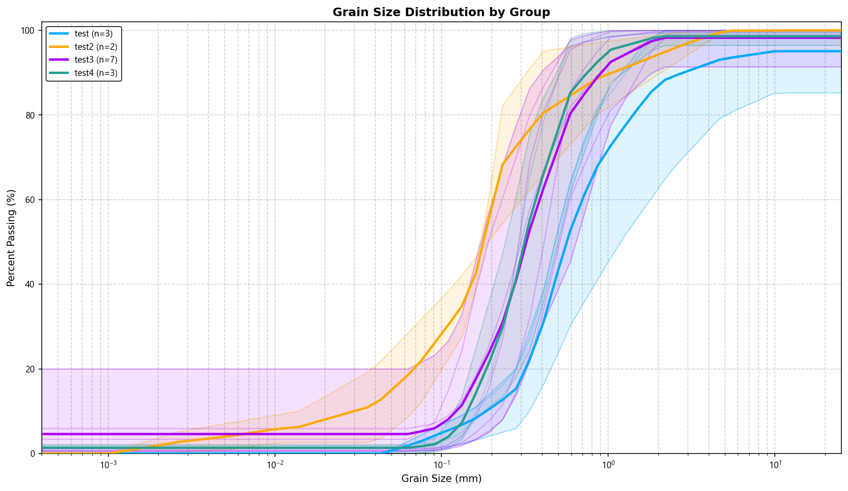

Hydraulic Conductivity by Method
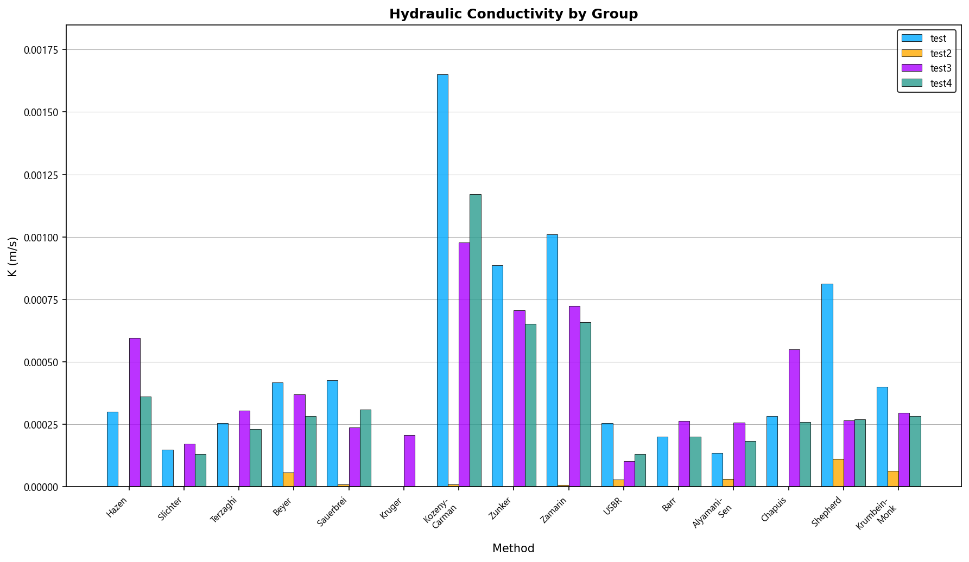

Hydraulic Conductivity Distribution
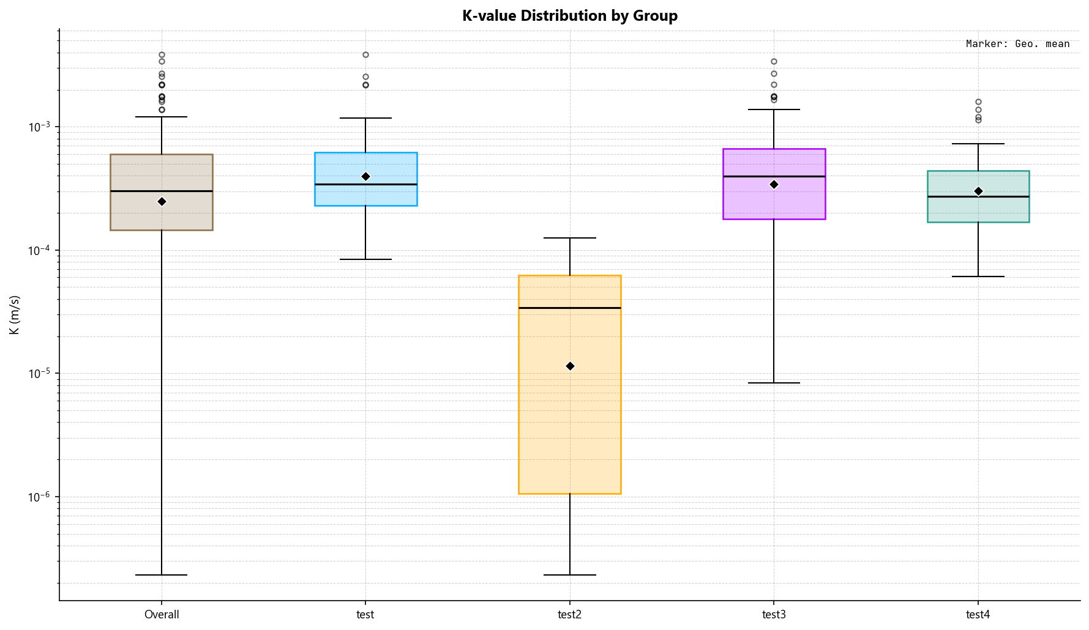

Individual Sample Plots

Example_1_Case_1_Vukovic
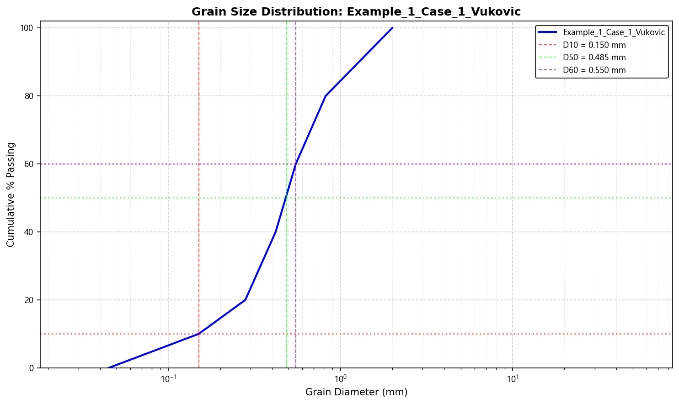
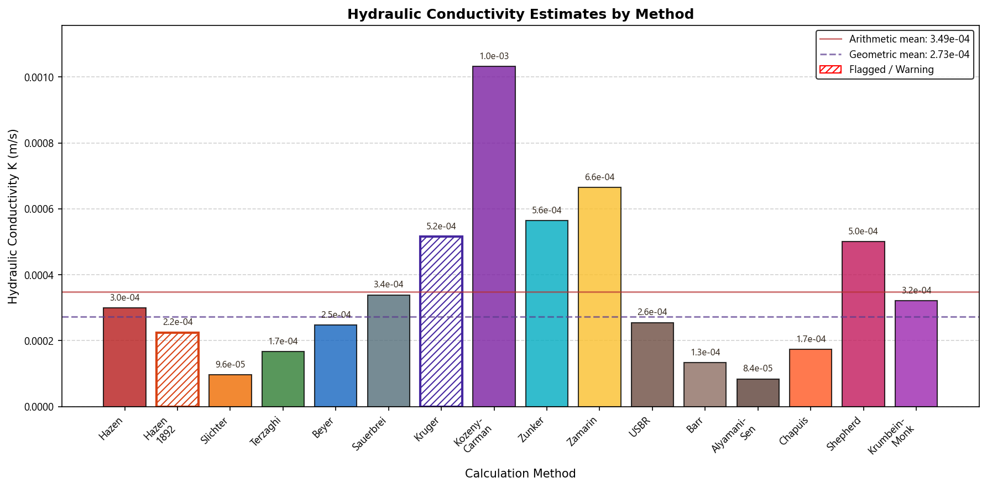

Example_1_Case_2_Vukovic_15C
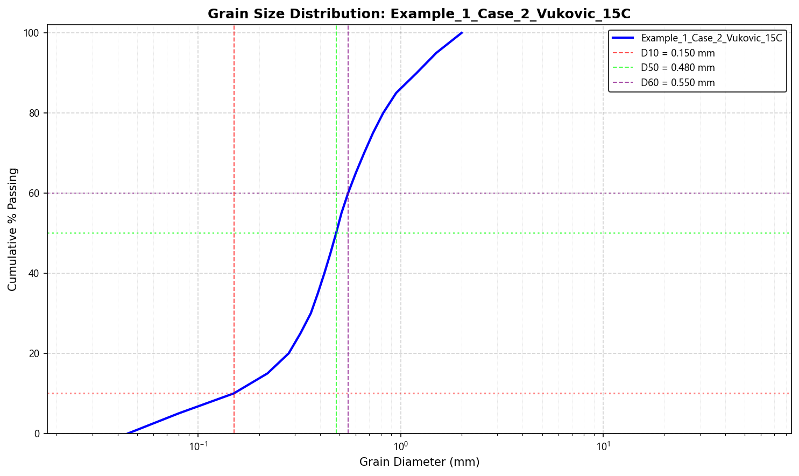
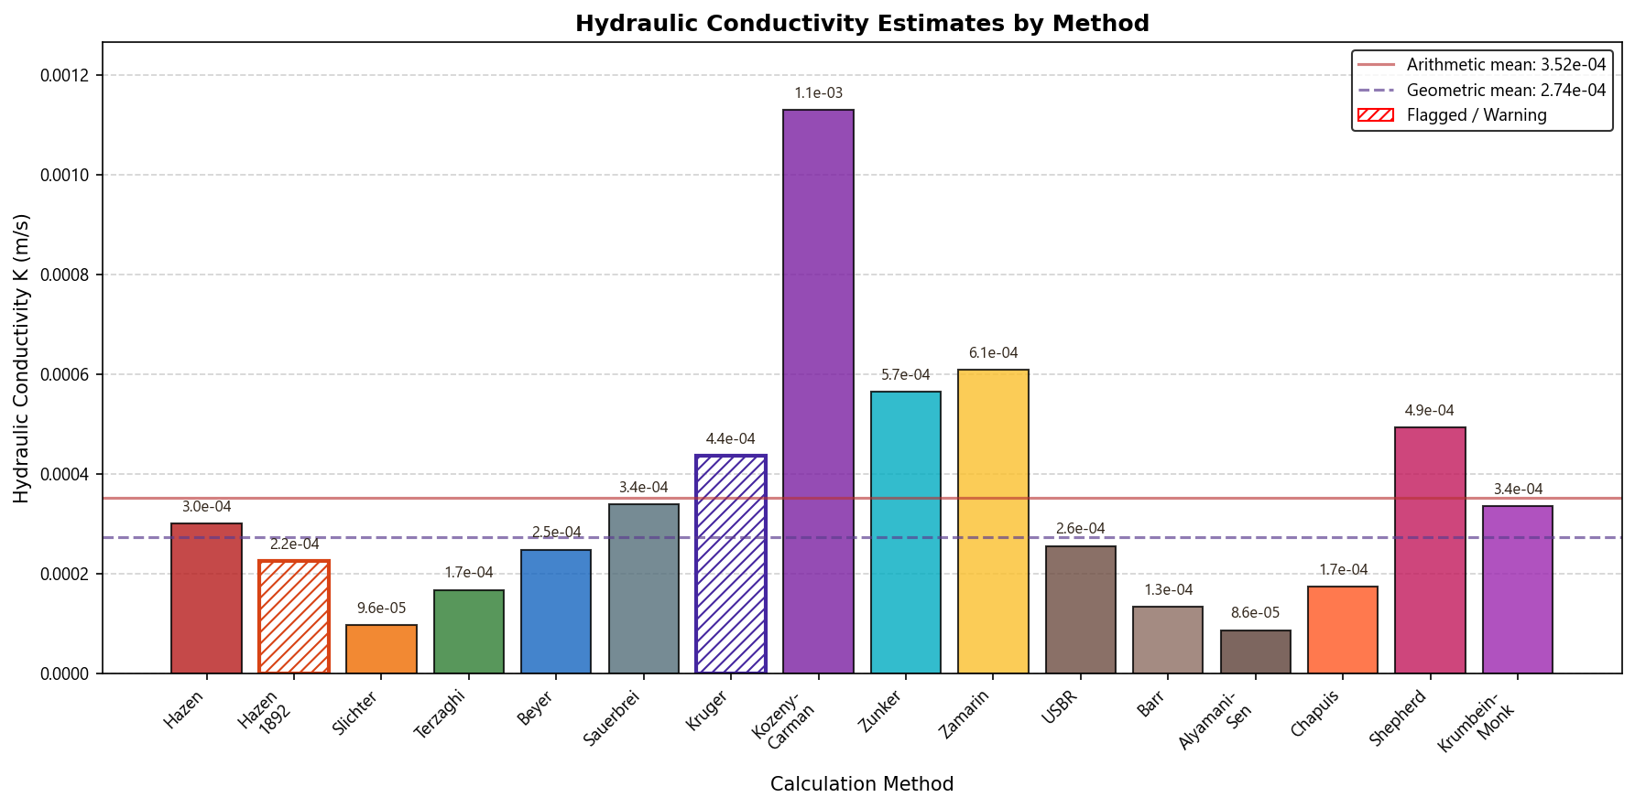

Example_2_Case_1_Vukovic_15C
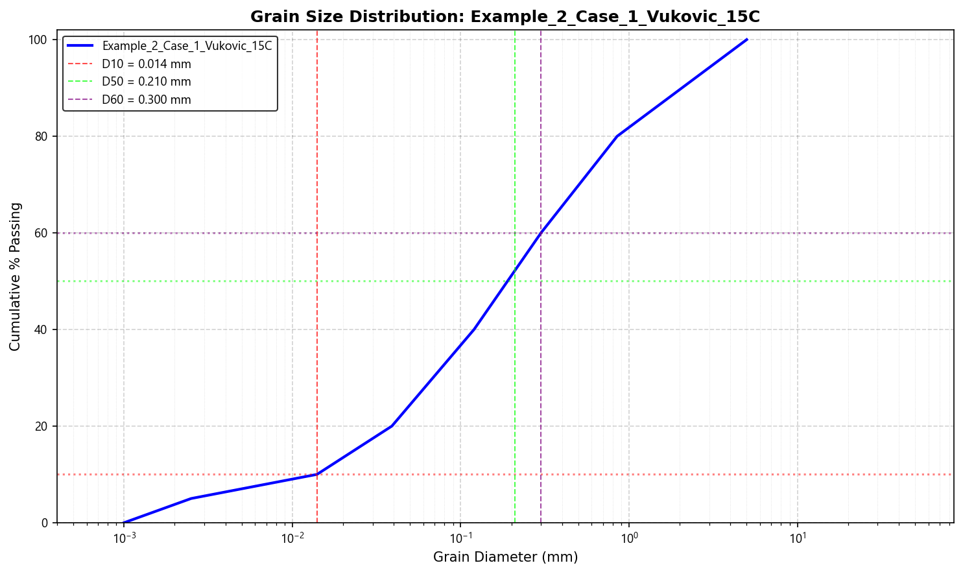
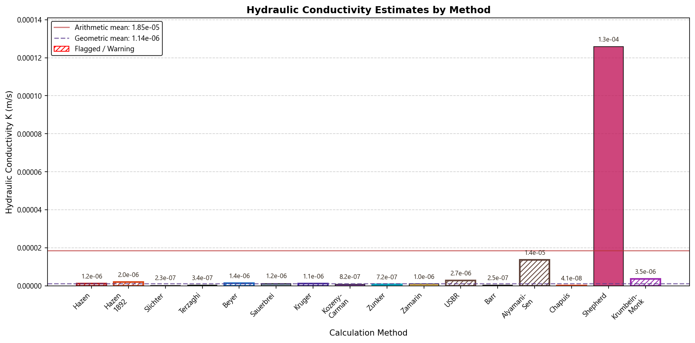

Sample_1_Odong
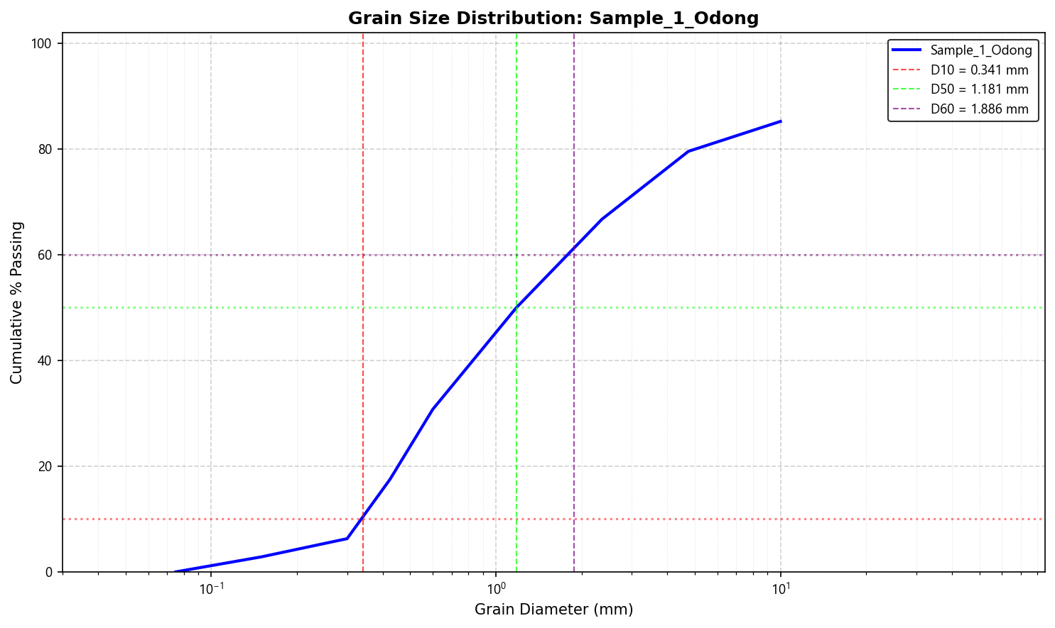
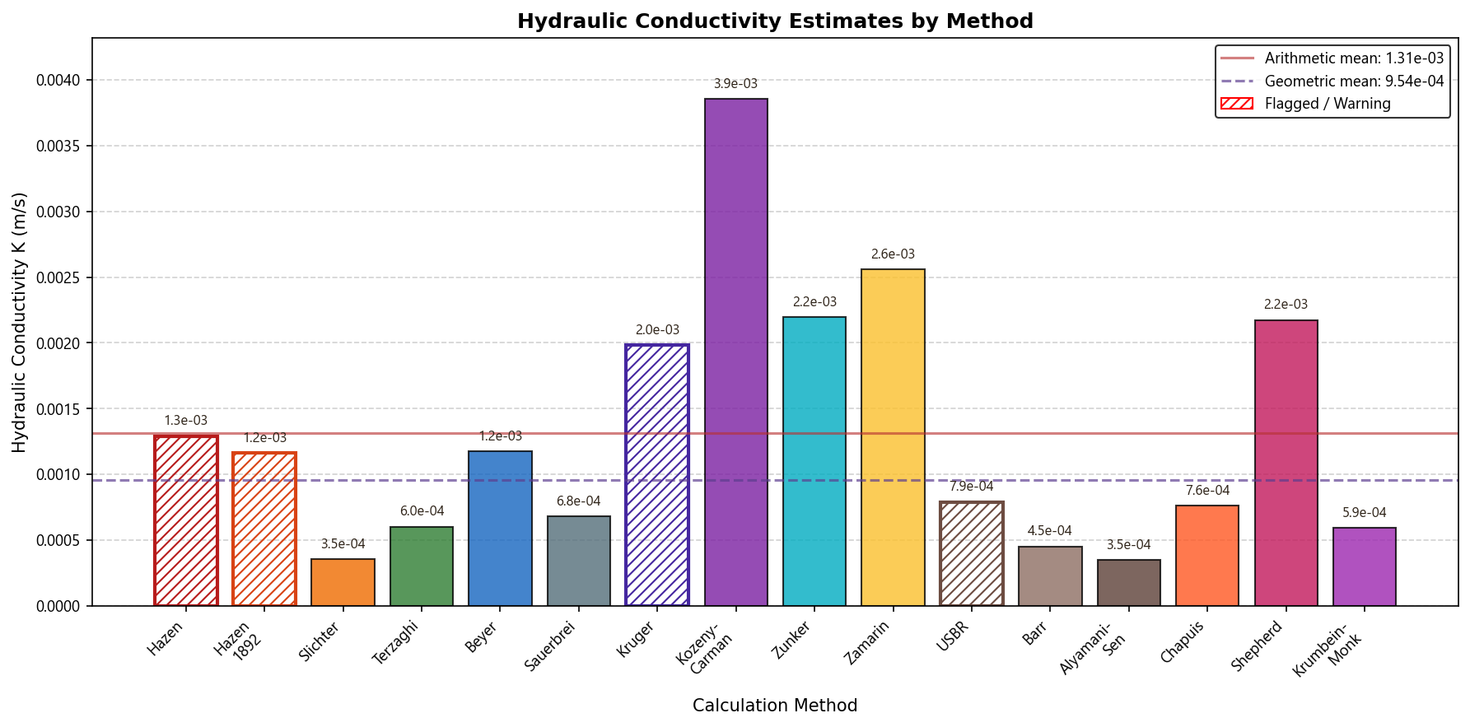

Thomson_SERDP_Borden_Sand
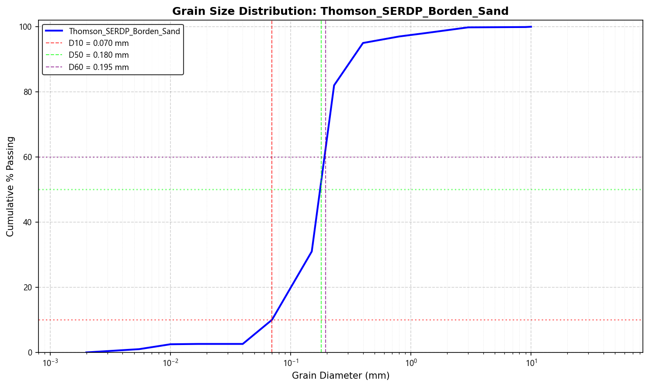
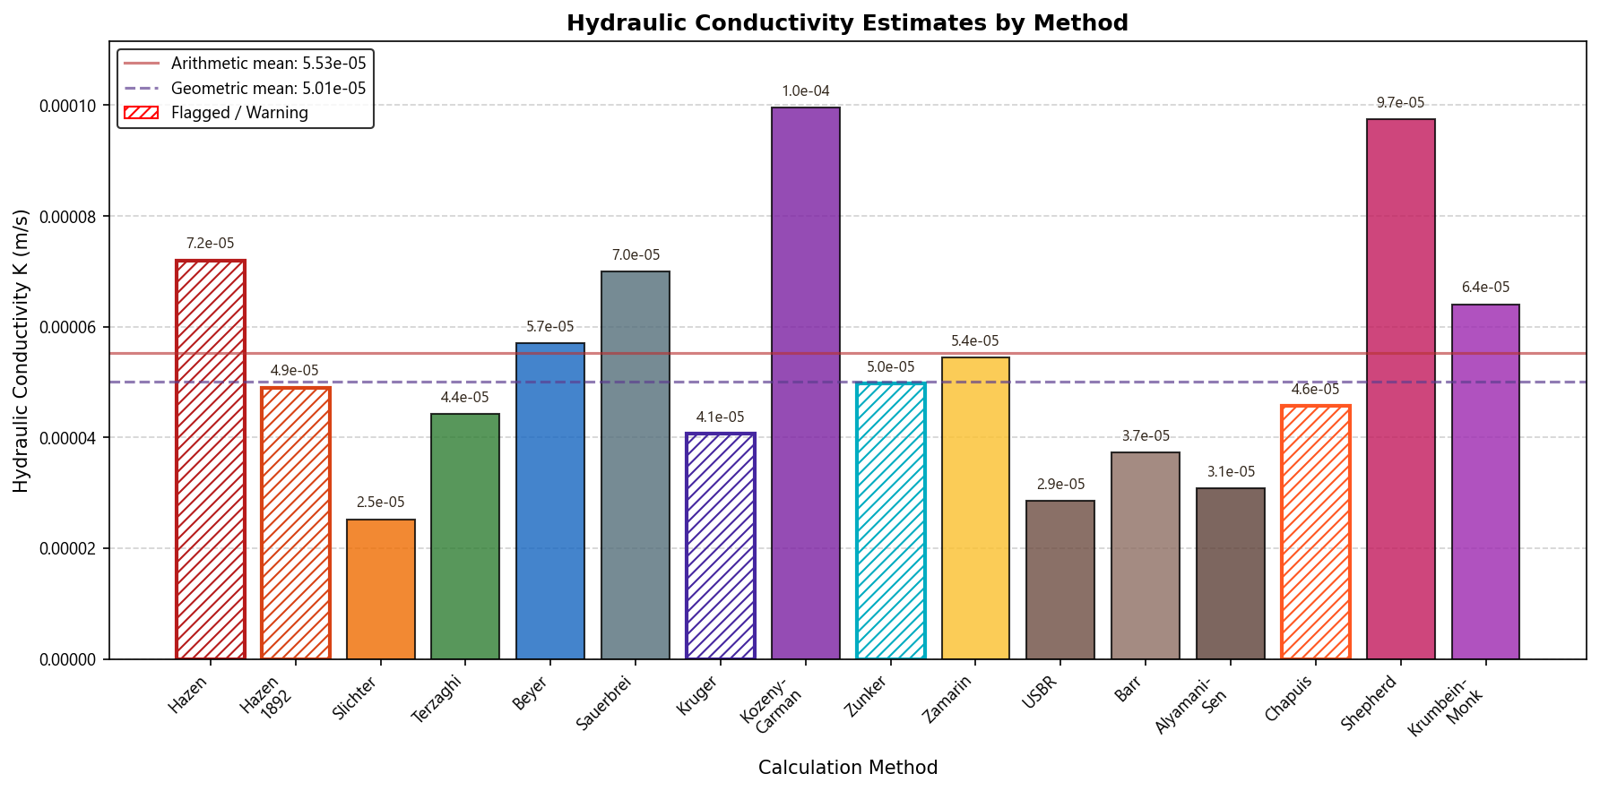

NBAL-01 [English]
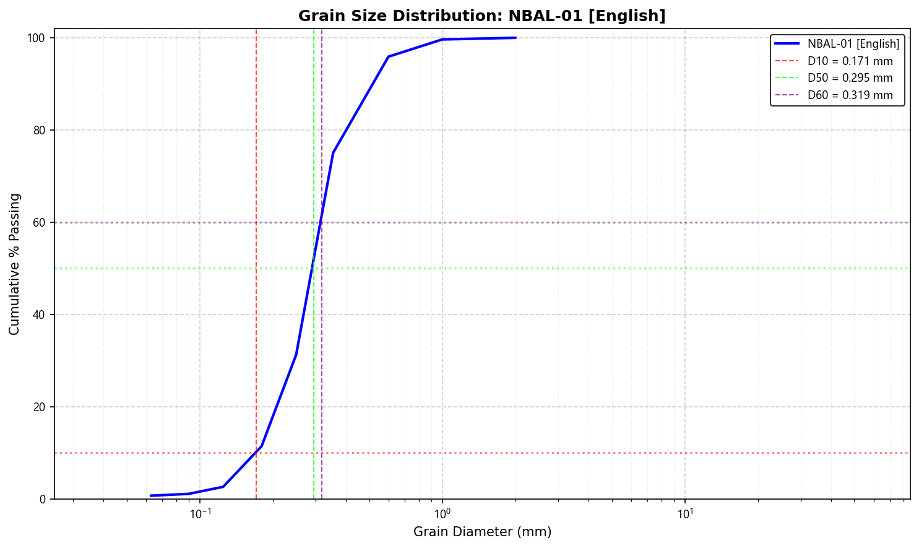
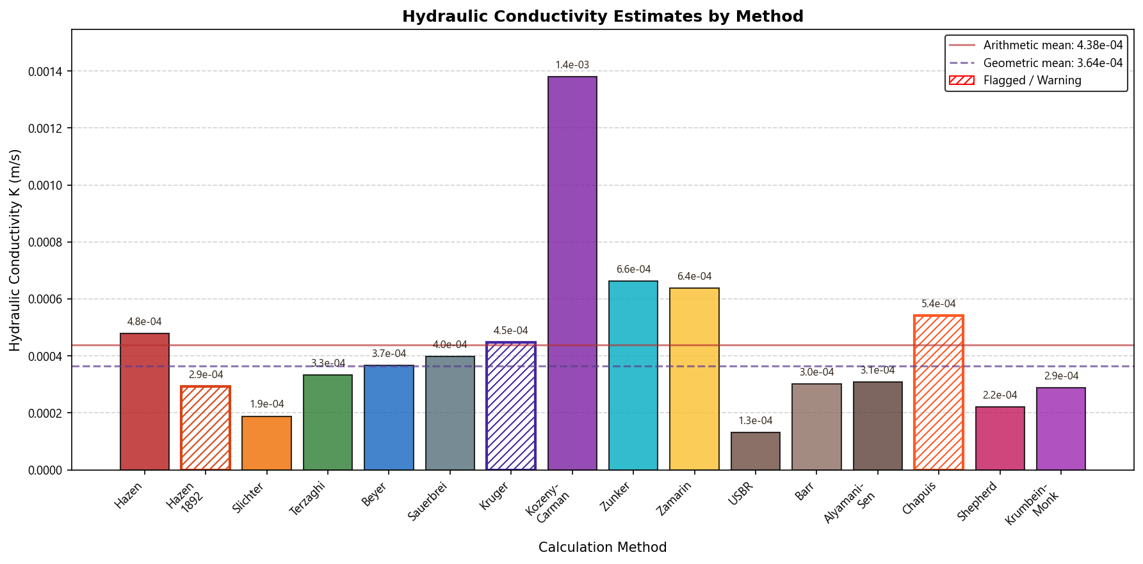

NBAL-02 [English]
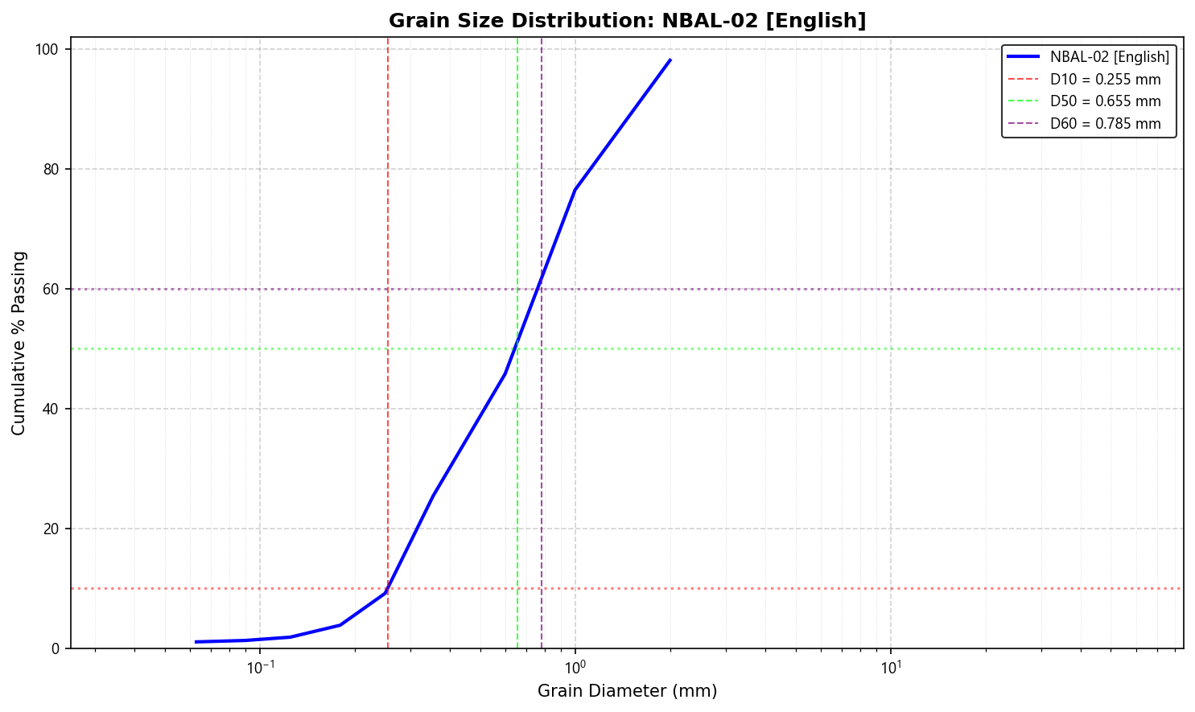
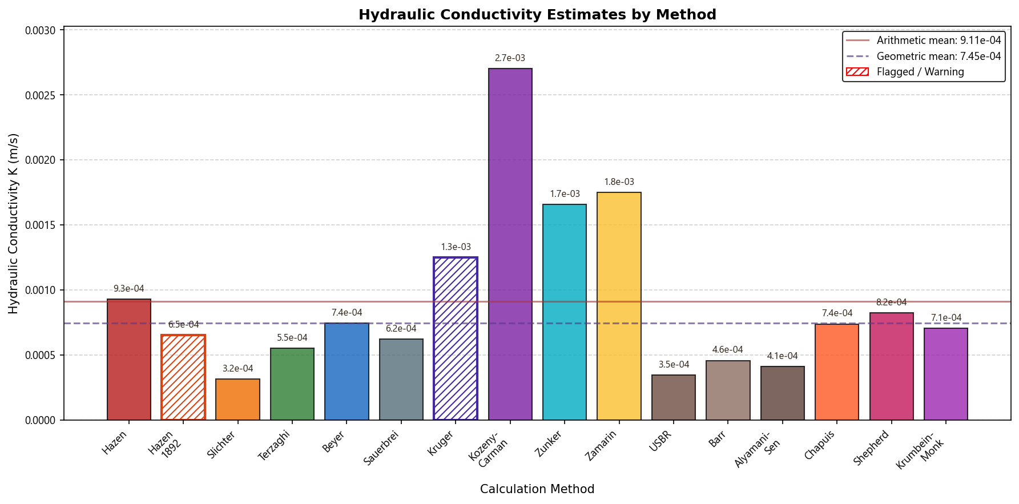

NBAL-03 [English]
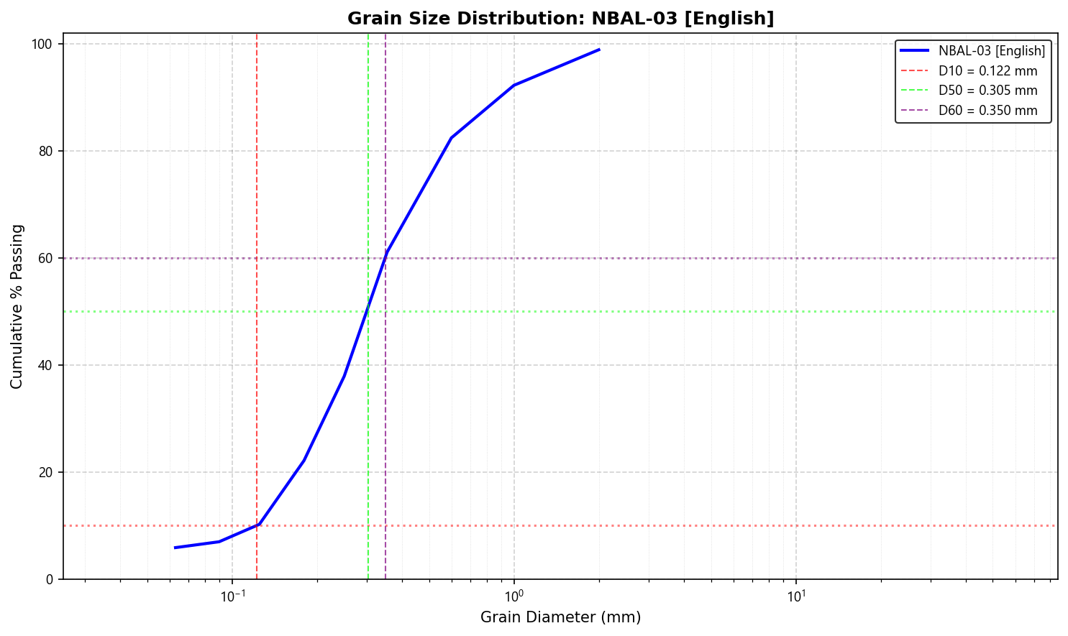
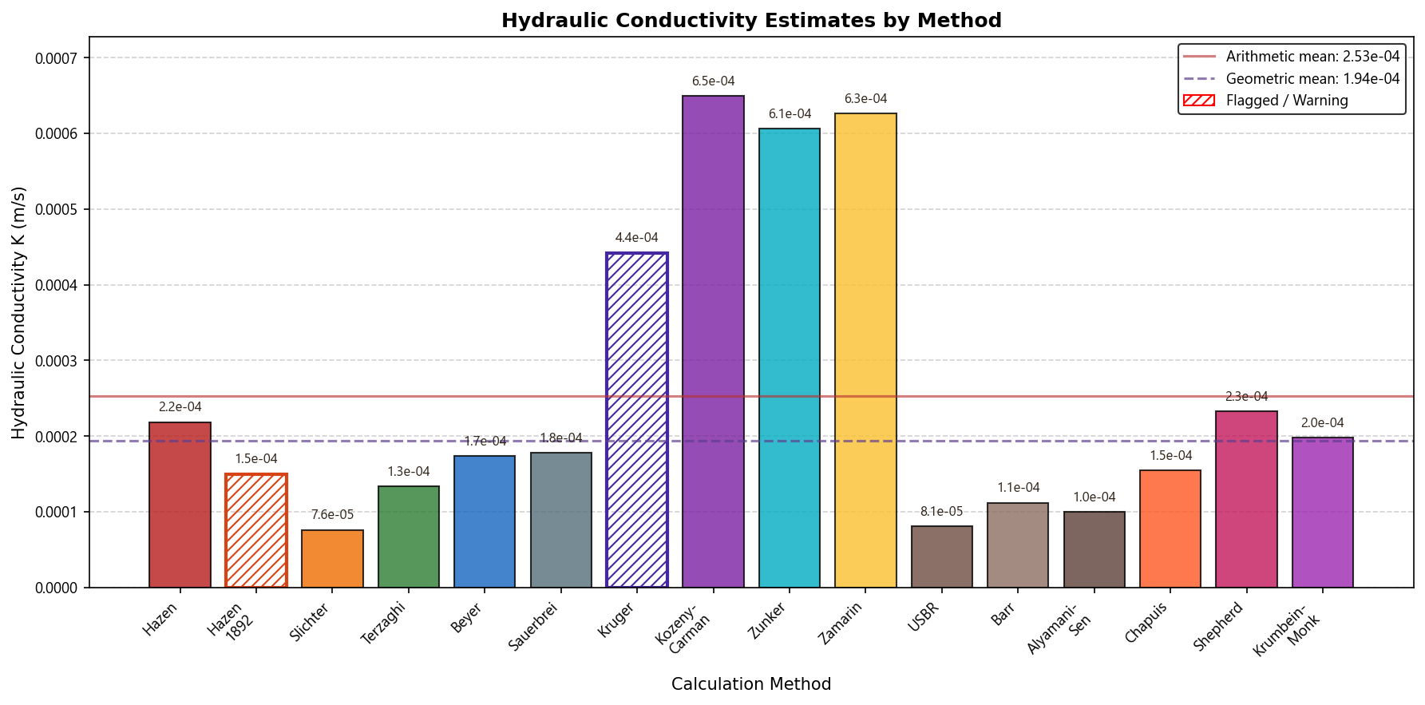

NBAL-04 [English]
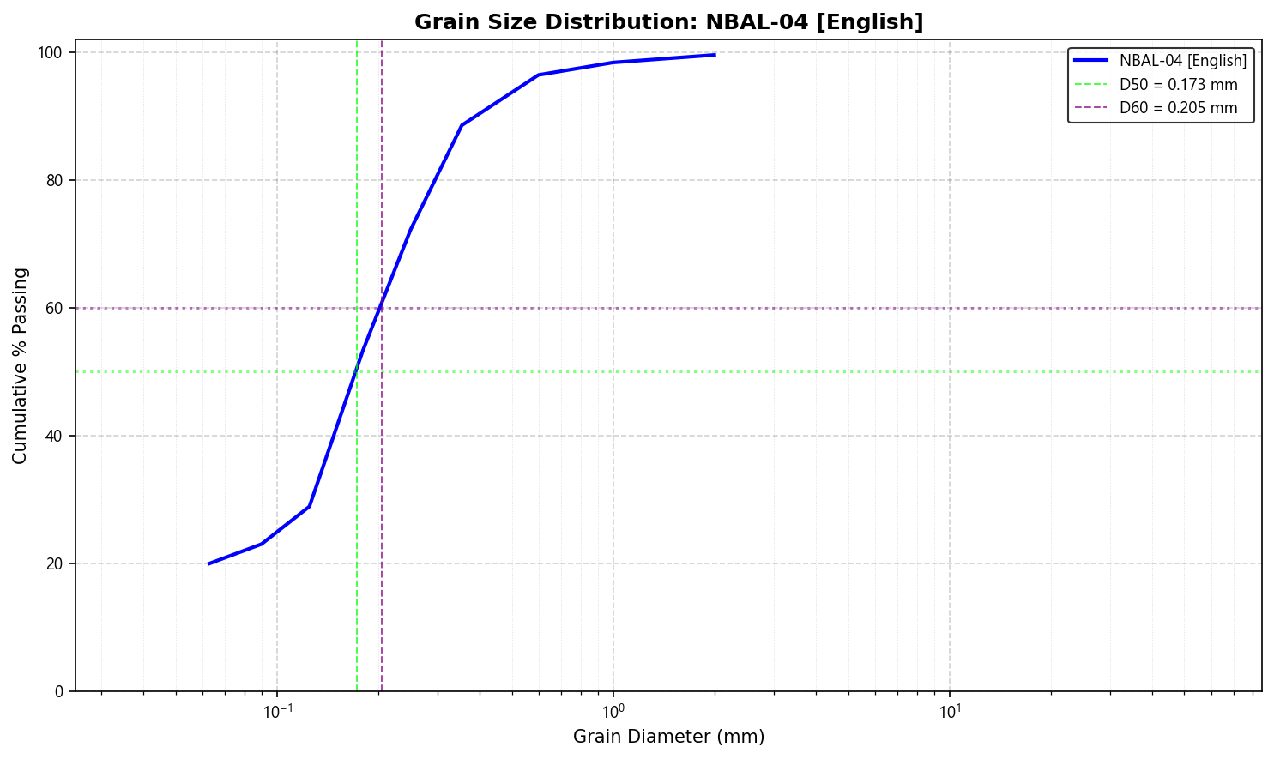
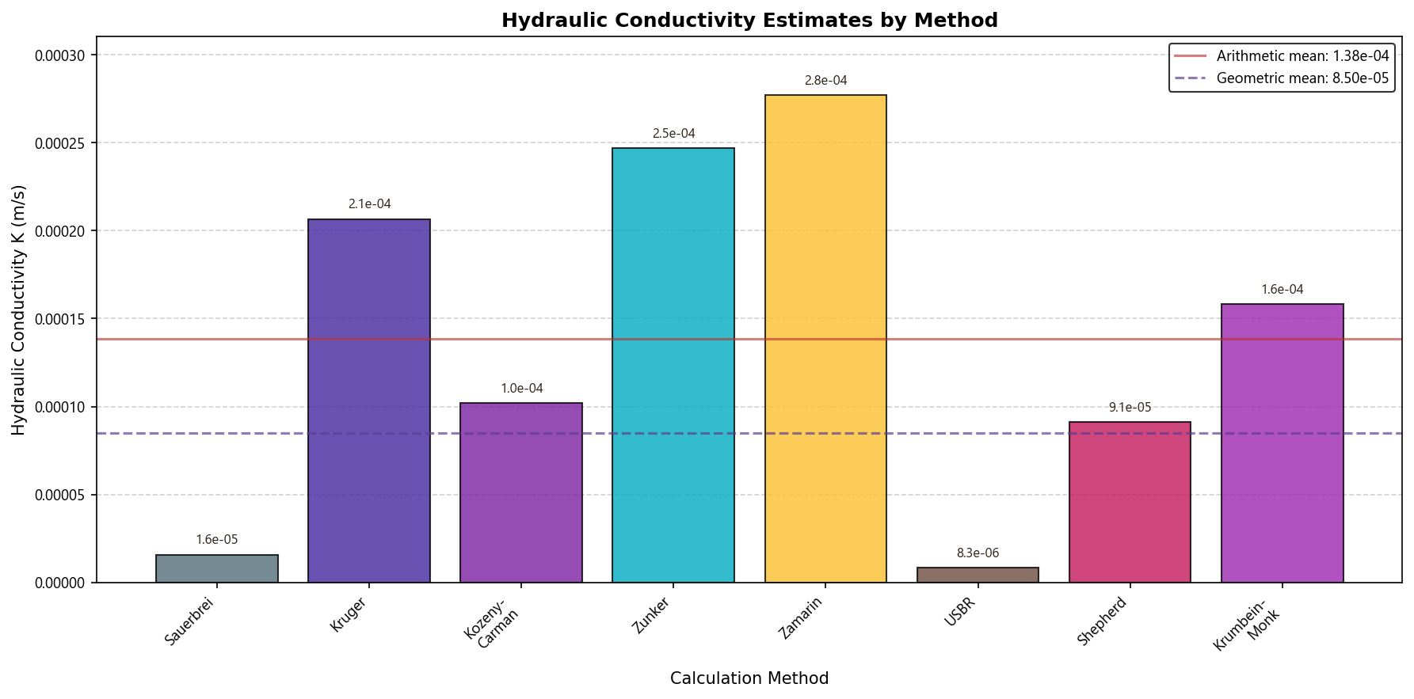

NBAL-05 [English]
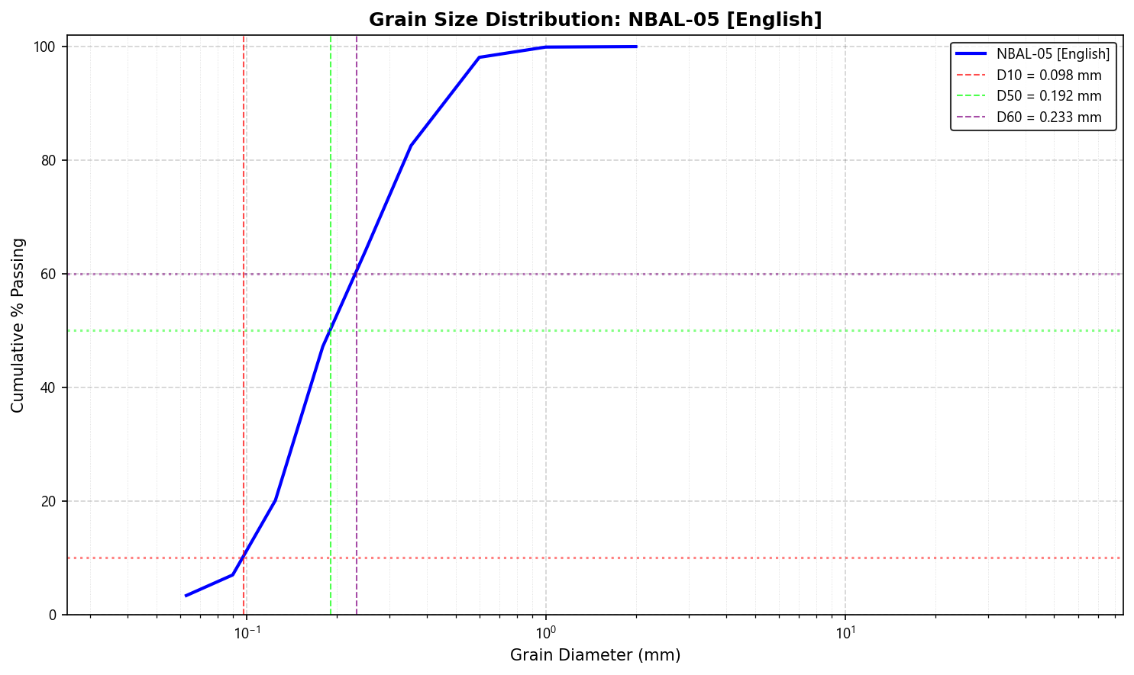
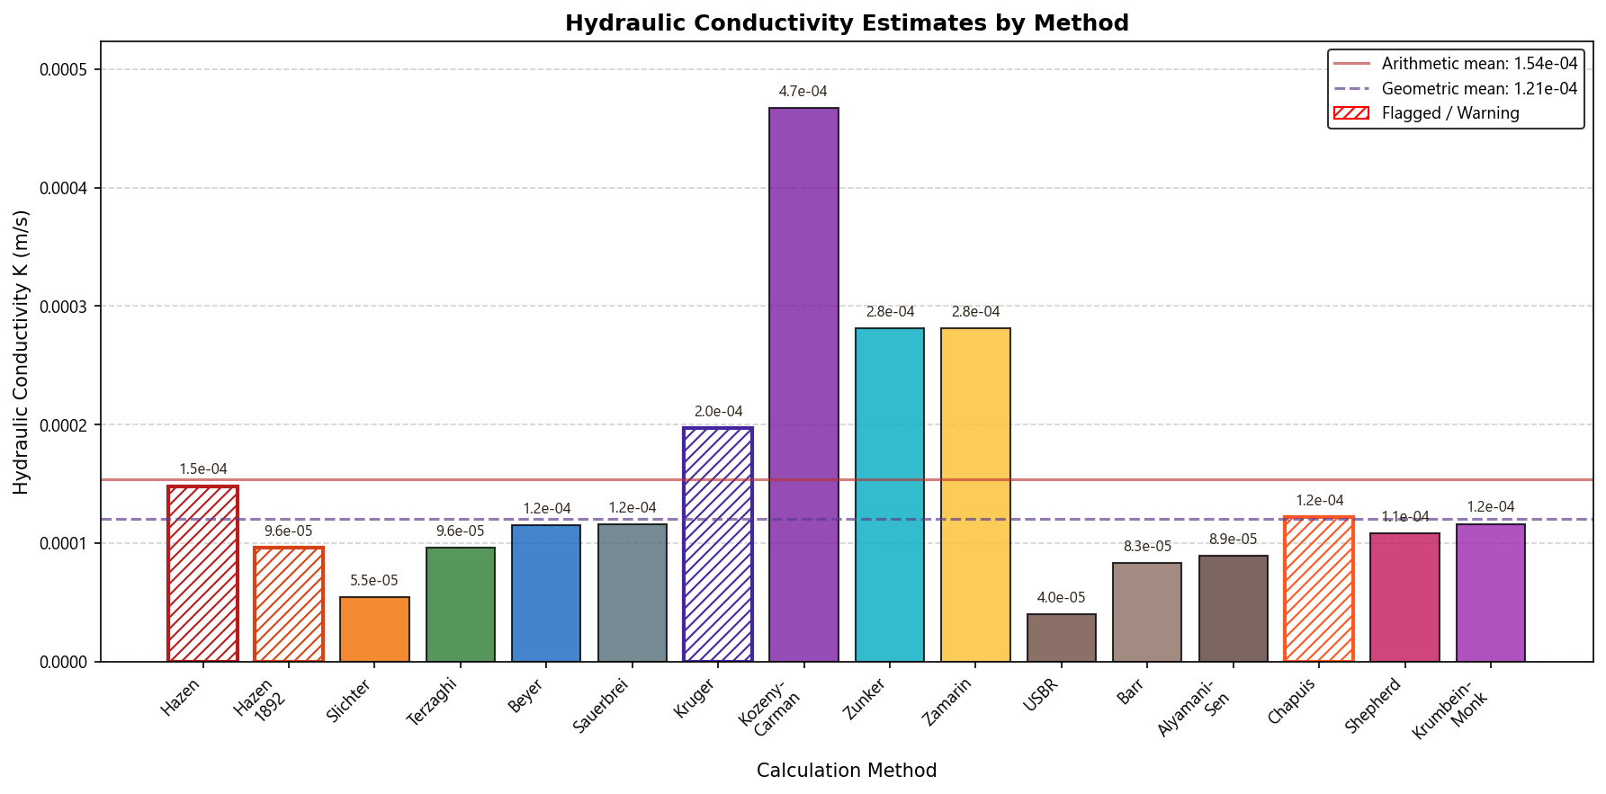

NBAL-06 [English]
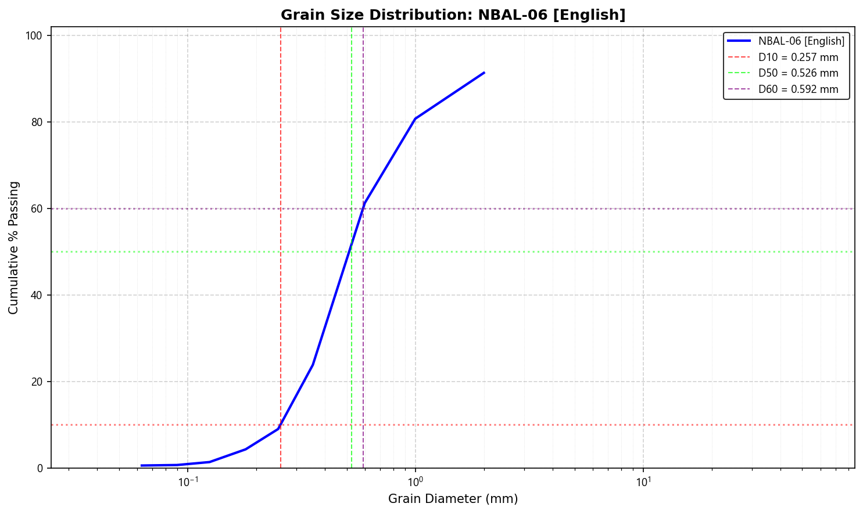
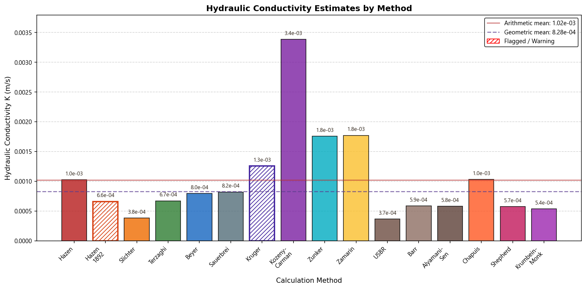

NBAL-07 [English]
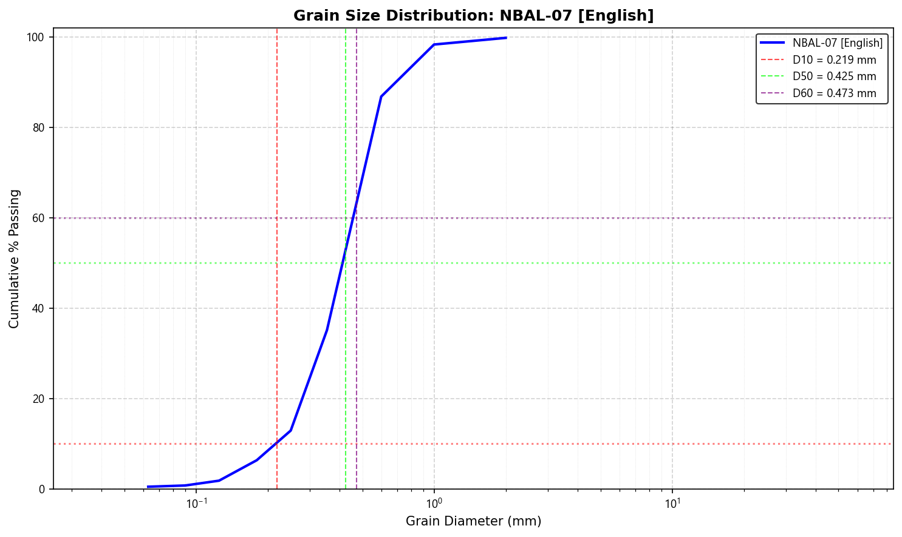
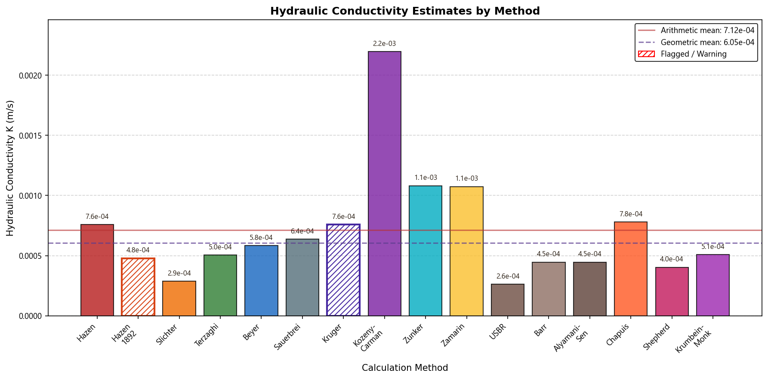

NBAL-08 [English]
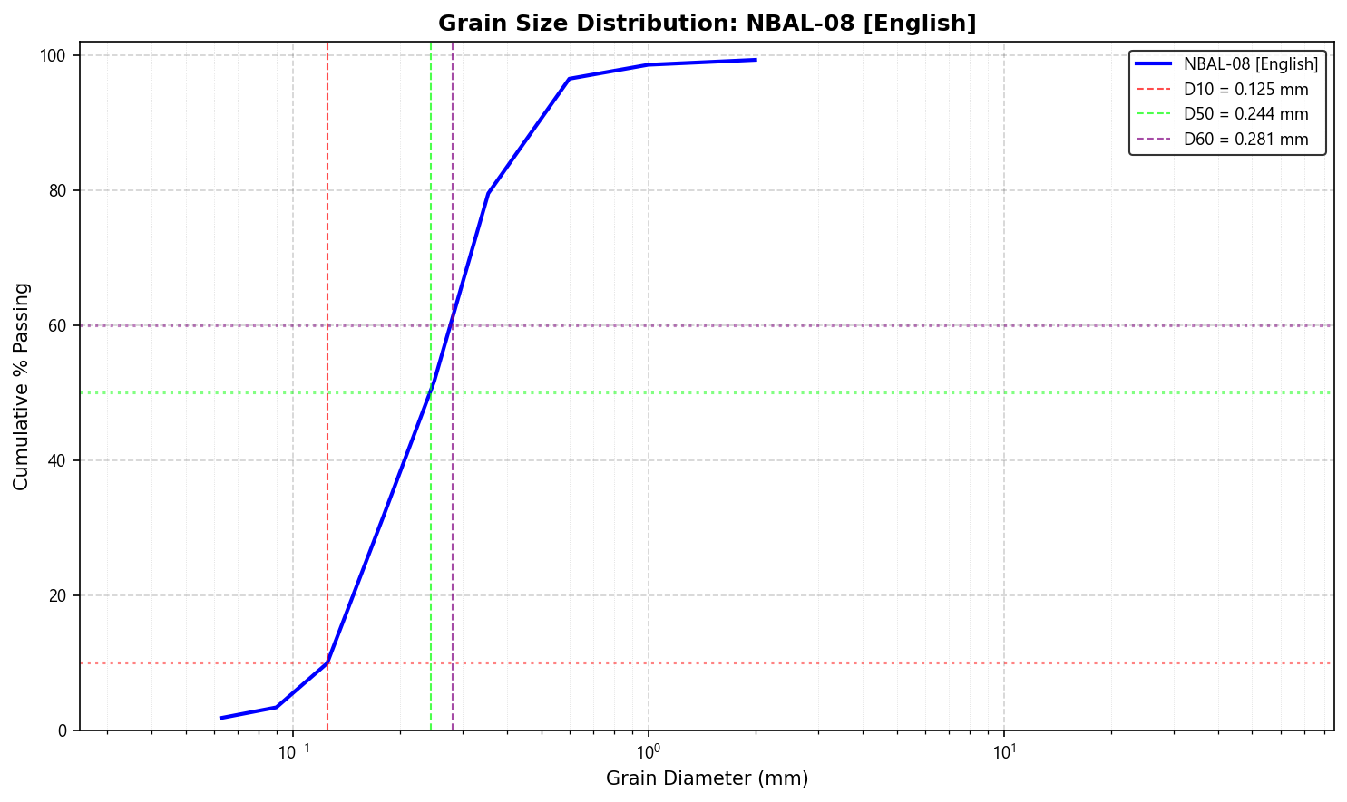
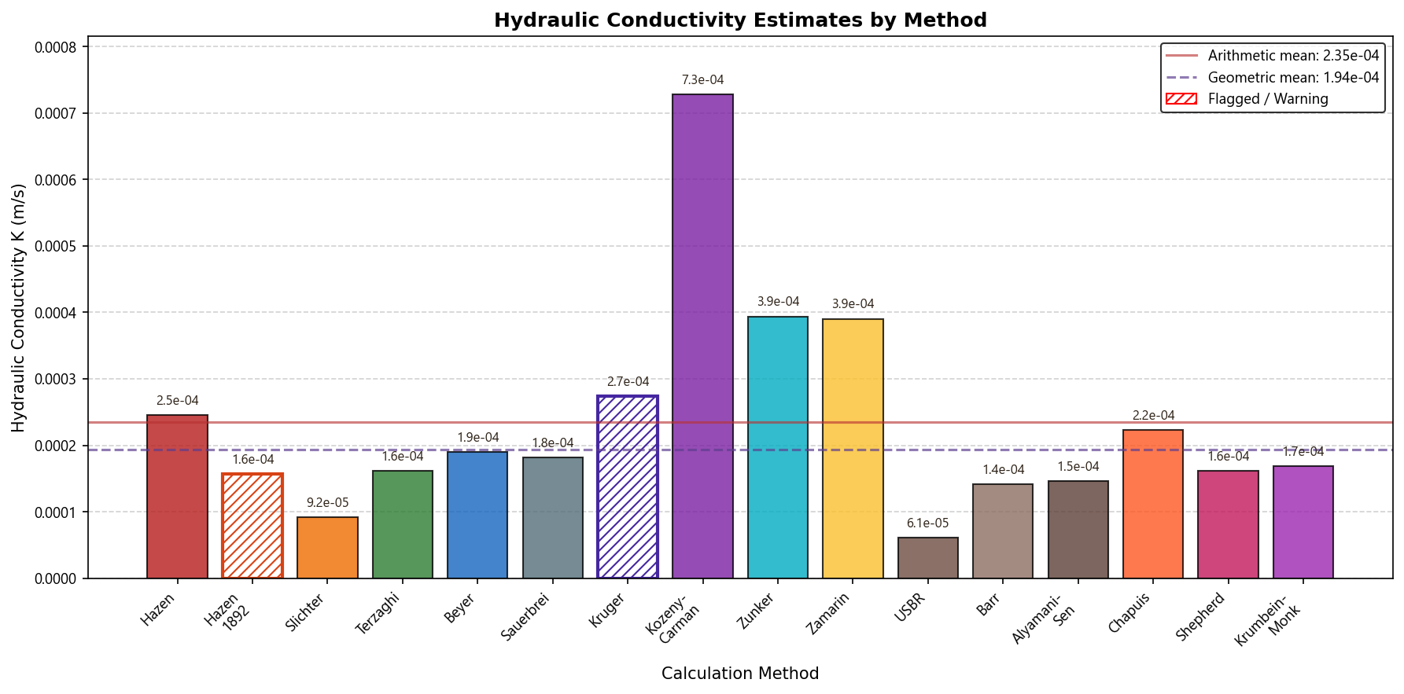

NBAL-09 [English]
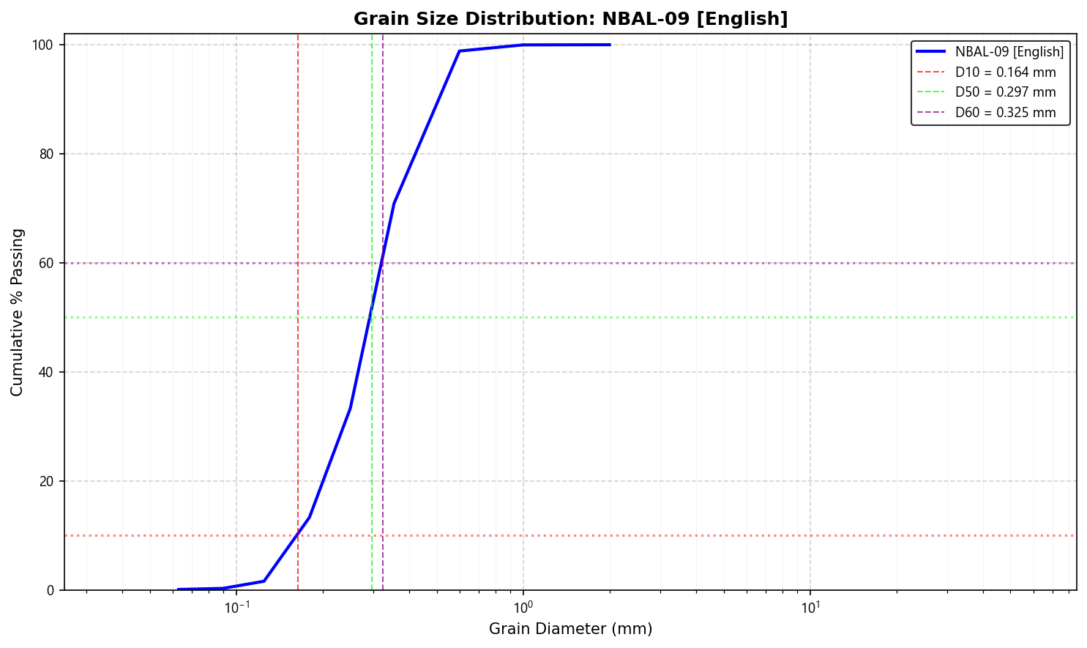
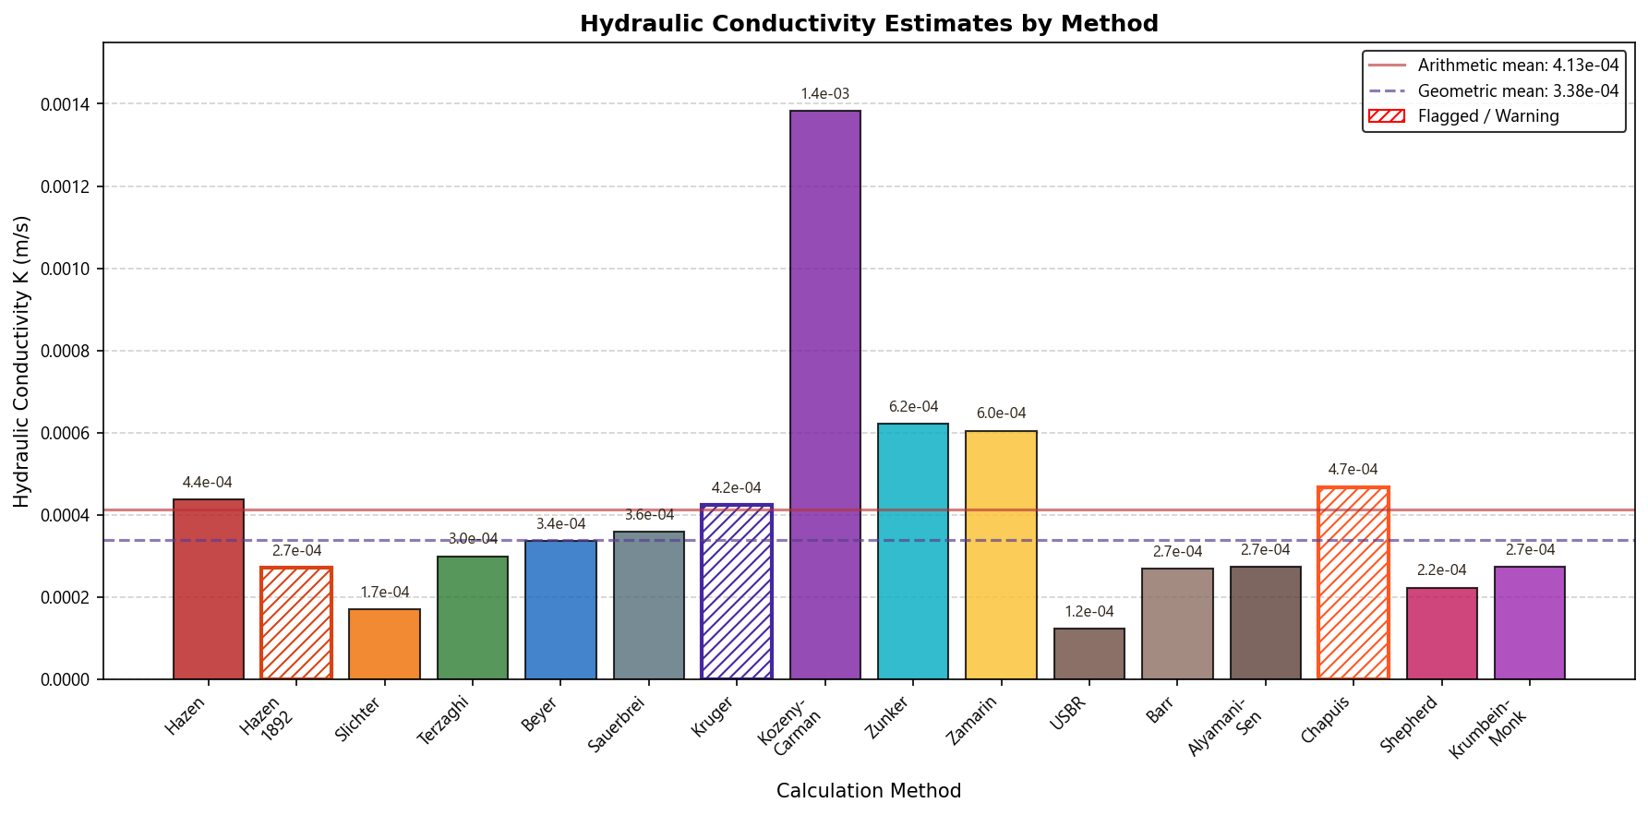

NBAL-10 [English]
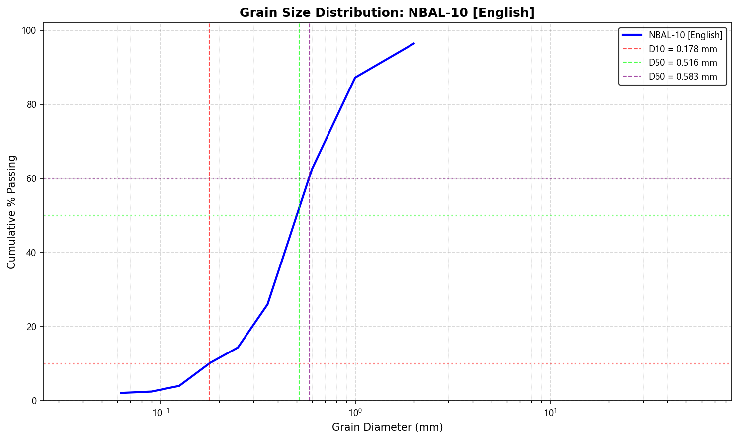
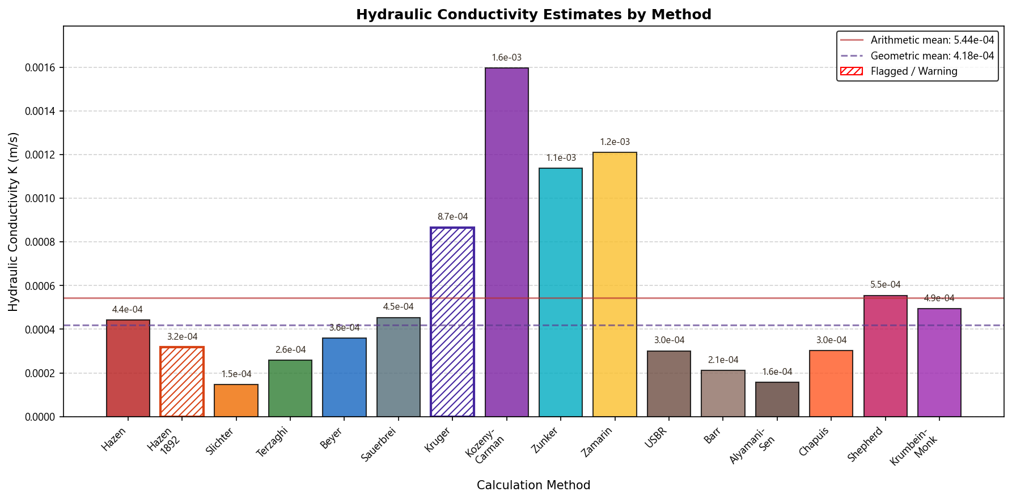

Interpretation & Discussion

Comparative Analysis
Permeability Characteristics:
- The highest permeability sample is Sample_1_Odong with K = 9.54e-04 m/s, classified as High (Clean Sand).
- The lowest permeability sample is Example_2_Case_1_Vukovic_15C with K = 1.14e-06 m/s, classified as Low (Silt).
- The 837.4-fold difference in permeability reflects the variability in grain size distribution among the samples.
Statistical Overview:
- Average sample K geometric mean: 3.63e-04 m/s
- Standard deviation: 2.84e-04 m/s
- Coefficient of variation: 78.3%

